Subject Specific Vocabulary
rally | Hitting the ball back and forth over the net without stopping.
control | Keeping the ball accurate and steady, not too hard or wild.
serve | The shot that starts a point; the ball must be hit into the opposite service box.
point | A score gained when your opponent cannot return the ball legally.
control point | A marker you must find; usually has a code to check you’re in the right place.
orientation | Lining your map up so it matches the direction you are facing.
terrain | The type of ground you are moving over (grass, path, slope, woodland).
map | A picture of the area from above that shows paths, buildings, and landmarks.
route | The path you choose to travel between control points.
compass | A tool that helps you find directions like north, south, east and west.
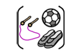

Year Five – PE – Outdoor: Tennis and Orienteering

 | Sticky knowledge
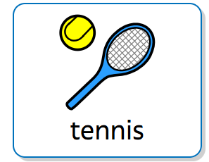  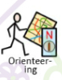 | Good tennis relies on accurate control of the ball, not just hitting it hard.
 | The two main strokes are the forehand and the backhand, each using a different side of the racket.
 | A point begins with a serve, which must land in the opposite service box.
 | Footwork helps players move into the best position to hit the ball effectively.
 | A rally is when players hit the ball back and forth over the net without stopping.
 | Orienteering involves using a map and sometimes a compass to find control points in the correct order.
 | A map must be oriented (turned to match the direction you are facing) to read it accurately.
 | Symbols and colours on a map help show features like paths, buildings and different types of terrain.
 | Good orienteering uses quick decision-making to choose the best route between control points.
 | Working safely and as a team—staying within boundaries and communicating clearly—is essential.

