Subject Specific Vocabulary
Christian | A person who follows the teaching of Jesus.
faith | Having complete trust in something.
belief | Accepting that something is true or exists without proof.
parable | A simple story used to show a mortal/spiritual lesson.
worship | To have or to show a strong feeling of respect to a God.
prayer | Words spoken to God.
Jesus | The son of God.
God | The creator and the ruler of the universe.
resurrection | The rising of Christ from the dead.
heaven | The place considered as the home of God.
Christmas, Easter, Harvest | Religious celebrations and important dates for Christians.


Year One – RE: Who is a Christian and what do they believe?
 | Sticky knowledge
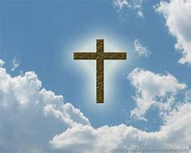 | Christians follow Christianity, believe and pray to God and follow Jesus’ example.
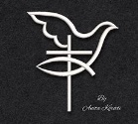 | The Christian symbols include fish, cross, dove, crucifix.
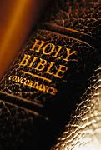 | The holy book of Christianity is called the Bible.
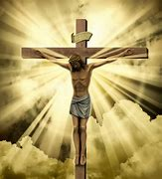 | Jesus is important to Christians because they believe he is the son of God.
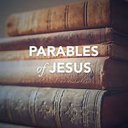 | Jesus told stories with morals and messages – these are called parables.
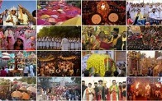 | People celebrate in different ways including singing songs, ways of worship, stories, artefacts, eating special food etc.
 | Christians celebrate festivals to remember. Christmas is to celebrate Jesus’ birth; Easter is to remember Jesus’ resurrection and Harvest is to remember the food grown on God’s earth.



Key Belief:
Jesus told many parables to guide Christians. They showed us why the fish, cross, dove and crucifix were important and taught us how to celebrate in different ways.

Key Belief:
Christians follow Jesus and pray to God. They follow Jesus by reading their holy book – the Bible.

