

Year One – Computing: Autumn

Subject Specific Vocabulary
log in | Using a username and password to access a system.
username | A name that is used by a person to access an online site.
password | A series of letters, numbers and special characters that is entered after the username to access an online site.
avatar | A digital picture to represent someone.
log out | Leaving a computer system.
save | Store your work as you create something so it can be accessed later.
 | Sticky knowledge
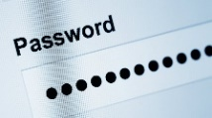 | It is important to use a password. If you share a password, others can access your account.
 | Technology should be treated with care.
 | You must not record others, when using technology.
 | A personal folder allows you to save information safely.
 | To stay safe online we shouldn’t talk to strangers and we must tell someone when you do not feel safe.
 | The author of a document tells you who owns it and who created it.





