 | Sticky knowledge
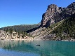 | Physical features are natural features on the Earth’s surface, such as water, lakes, mountains and deserts.
 | Human features refer to something that is built by humans and would not have existed in nature without humans. Features include anything from a house to a city, and all the related infrastructure such as roads, rails and canals.
 | “My address is _________”.
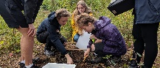 | Fieldwork and geographical investigations are about finding out new things about people, places and environments.
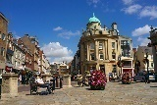 | A town is bigger than a village with more houses (and people), schools and usually a train station.
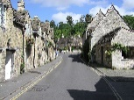 | A village is a small settlement with some houses, shops and sometimes a small school. A town is bigger than a village with more houses (and people), schools and usually a train station. A city is often bigger than a town with lots of buildings close together, high populations and advanced transport systems.
 | England, Scotland, Wales and Northern Ireland make up the United Kingdom.
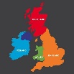 | Great Britain is part of the United Kingdom, Great Britain is an island (land surrounded entirely by water), Great Britain is made up of three countries: England, Scotland and Wales. The United Kingdom includes these three countries and Northern Ireland.
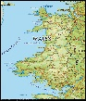 | Wales is to the west of the UK and is surrounded by water on three sides. It has coasts, mountains and valleys.
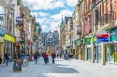 | England is the largest country by land size and population. It has large cities such as London, Birmingham, Nottingham and Manchester.
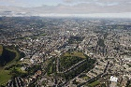 | Aerial photographs are shown from above. Geographers use them to recognise landmarks and features.
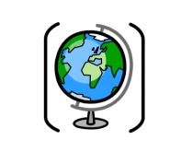

Year One – Geography: What makes us proud of where we live?
Subject Specific Vocabulary
human features | Features that are man made. These include houses, shops, and roads.
physical features | Features that are natural. These include lakes, mountains and rivers.
town | A built up area that is larger than a village, but smaller than a city. Towns have more shops, houses and usually a train station.
city | A city is larger than villages and towns. It is a built up area which often has a cathedral.
village | A village is small area that has some houses, shops and sometimes a small school.
ariel photographs | Ariel photographs are taken from above and look like a ‘birds eye view’.
fieldwork | An investigation that helps us find out new things.

Sticky Knowledge

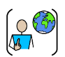
Belonging is where we feel loved and accepted. Belonging can be felt in a certain place or with a certain person.

Collage is a piece of art made by sticking various materials together on to a backing.
I can like a piece of art because of the colours, style or how it makes me feel. “I like _______ art because it _________________.”
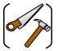
A functional product is something which is practical and useful.
Running stitch is a continuous line of stitches with gaps between them.
Products can be moved by pushing or pulling.



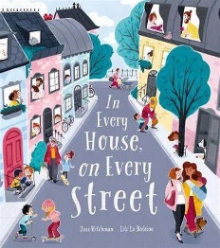
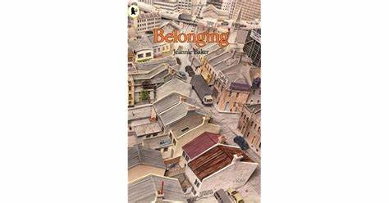
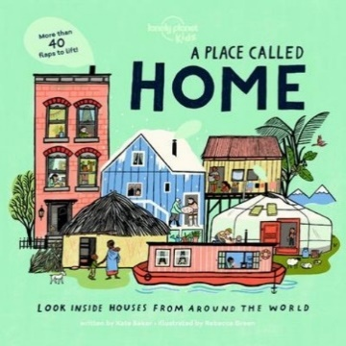
Primary and Secondary sources can help us to find out information.
Exciting texts!

