Subject Specific Vocabulary
instruments | An object or device for producing musical sounds.
pitch | The quality of a sound caused by the rate of vibrations producing it.
pulse | A single vibration or short burst of sound.
tempo | The speed at which a passage of music is or should be played.
melody | A sequence of single notes that is musically satisfying, a tune.
dynamics | The varying levels of volume of sound in different parts of a musical performance.
style | A particular type, form or quality of music.

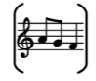
Year One – Music: Autumn
 | Sticky knowledge
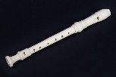 | Music can be made by one instrument.
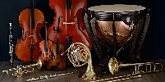 | Music can be made by lots of instruments.
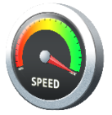 | Tempo is the speed of music.
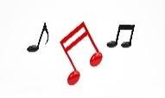 | Melody is the tune of music.
 | Music can make me move in different ways.



