
Year One – PE: Autumn 1
 | Sticky knowledge
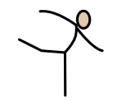 | Gymnastics  Using space wisely is important for Gymnastics
 | There are different types of movements that make up Gymnastics
 | Creativity is creating our own ways of moving and balancing
 | Collaboratively is working together effectively.
 | Linking is joining two or more movements together to make a sequence
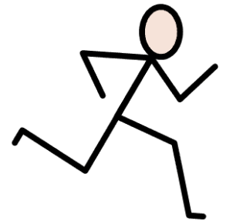 | Running  When attacking and defending, we need to use space carefully to avoid defender/attackers whilst using our running skills.
 | Running fast and slow is a deliberate choice to help me know when to run and where to run to be successful in game scenarios.
 | When playing in a game, we must listen, play by the rules and encourage others.
Subject Specific Vocabulary
Narrow | Moving or balancing by stretching arms and legs vertically.
curled | Move or balance by rolling our body up tightly.
Wide | Moving or balancing in ways where the body is extended, arms and legs away from the centre of the body.
Transition | Moving in and out of movement, actions or balances.
Linking | Adding two or more movements together so that they flow one after the other.

Subject Specific Vocabulary
Attacker | Person avoiding defender to get a point.
Defender | Person trying to tag an attacker and stop them from scoring.
Space | An open area on the pitch.
Speed | Moving all parts of the body as quickly as possible.
Acceleration | How quick an athlete can increase their speed.
Tagging | How to stop an attacker from moving.

