
Year One – PE: Autumn 2
 | Sticky knowledge
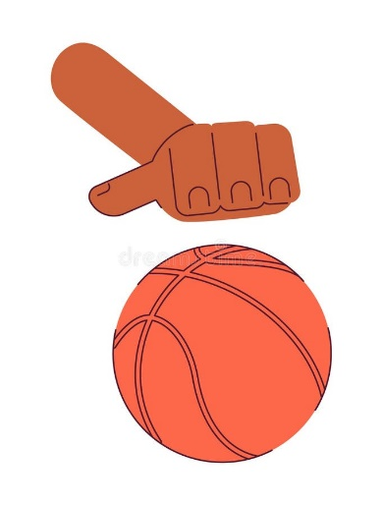 | Hands  Aiming carefully and applying the correct technique will help send a ball towards a target.
 | Communicating with a partner will help when passing the ball.
 | Reflecting is when we think back to how well we have used our success criteria.
 | Fairness and empathy means we can show how well we can work with others and play by the rules
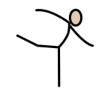 | Body Parts  We can use big and small body parts in wide, narrow and curled ways.
 | We can move in a variety of different ways and understand the difference between each type of movement.
 | Creativity is when we use our own ideas to link different movements together.
Subject Specific Vocabulary
possession | When we have physical control of the ball.
space | An open area on the pitch
control | Keeping the ball close to us when we are dribbling.
dribbling | A method of moving the ball by continuously bouncing.
Accuracy | The ability to control the ball where we roll bounce or push a ball.

Subject Specific Vocabulary
Wide | Moving with arms extended away from the centre of the body
Narrow | Moving with arms vertically positioned from the centre of the body.
Curled | Rolling our body up tightly
Big | Moving or balancing in way where the body is made as big as possible
Small | Moving or balancing in way where the body is made as small as possible
Linking | Adding two or more movements together so they flow one after another.

