Subject Specific Vocabulary
plants | A living thing that grows in the earth.
leaves | A part of a plant that is usually green. They are attached to the stem.
flower | Usually a colourful part of the plant made up of petals.
roots | Part of the plant that is underground. They take water from the soil into the plant.
tree | A large plant with a stem made from wood.
petals | Colourful parts of a plant that make up the flower.
stem/stalk | The part of the plant from which all the other main parts grow.
trunk | The wooden stem of a tree.
branches | Parts of a tree that grows from the trunk.
seeds | What a plant grows from.
observe | To look carefully.
magnifying glass | A piece of scientific equipment used to observe detail carefully.
seasons | Parts of the year.
Autumn | The season between summer and winter.
Winter | The coldest, darkest season.
sunrise | When the sun comes up.
sunset | When the sun goes down.
sleet | A mixture of snow and rain.
 | Sticky knowledge
Examples of wild plants are a nettle, bluebell, poppy, daisy and buttercup.
A wild plant grows where the seeds fall, it does not need to be planted and does not need to be cared for as it grows. If a wild plant grows where it is not wanted, it may be called a weed.
Deciduous trees lose their leaves in Autumn. Some examples of deciduous trees are oak, birch and sycamore.
Evergreen trees stay green all year. Examples of evergreen trees are holly, yew and pine.
The parts of a plant/tree are – stem/stalk, leaves, flower, roots, petals, trunk, branches, bark, blossom.
The Winter months are December, January and February.
In Winter, the trees are bare.
The days in winter are coldest and the shortest and there is sometimes snow and sleet. You need to wear more layers in the winter.
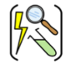

Year one – Plants and seasonal change.
Aspirational Scientist:
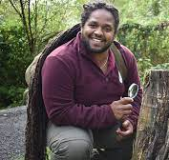
Yamza Hassin
Yamza is a wildlife camera man. He studied zoology, conservation and biological photography at university. He has appeared on several television programmes including – Ranger Hamza on cbeebies, Animal Park and Countryfile.

Working Scientifically

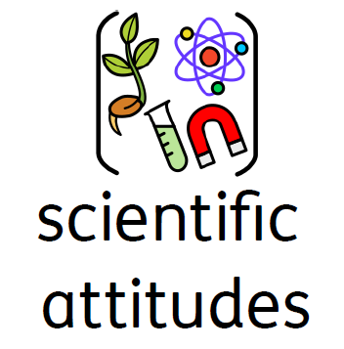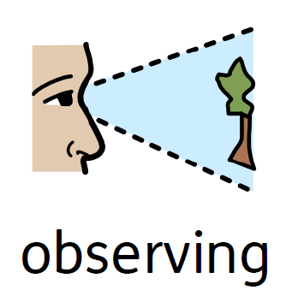

Working Scientifically

