Subject Specific Vocabulary
safety | being protected from anything likely to cause danger or injury.
safeguarding team. | a group of people who work together to prevent risks and harm to children
age limits | rule for which there is a minimum age to do something.
dangers | an action that can cause harm or injury to you.
risk | actions that could cause you harm
harm | an injury that is caused physically or emotionally.
unique | being the only one of its kind and unlike anything else
mutual respect | value and respect different opinions and beliefs
challenge | being faced with something that requires great physical or mental strength.
strangers | an adult or child you are not familiar with.

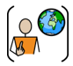
PSHE Year 1 Autumn
 | Sticky knowledge
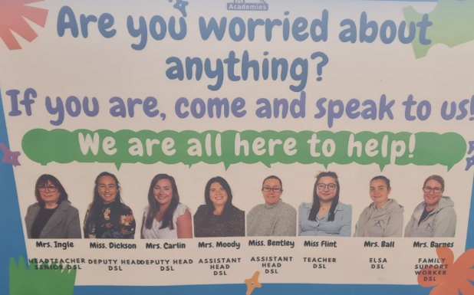 | The safeguarding team and trusted adults at school can keep us safe.
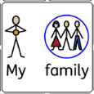 | People who care for us and love us include our families, friends and people in our communities
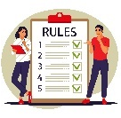 | Rules can keep us safe like wearing our helmets when we cycle to protect our heads.
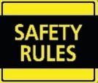 | There are rules we can follow to keep ourselves safe at school and at home.
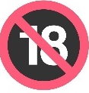 | Age limits are there to protect us.
 | Unique means that we are one of a kind and that is what makes us special.
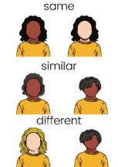 | There are lots of ways we are the same and lots of way we can be different to each other.

