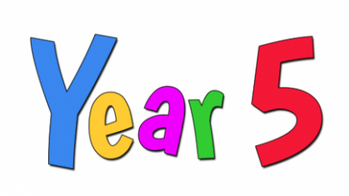Spring Term 2026 |  | 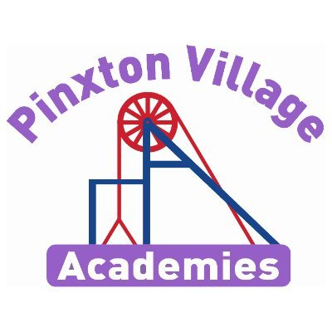
Year 5 Newsletter
Welcome back!

Welcome back and welcome to 2026! We hope you have all had a super Christmas break and are feeling well rested and ready for a busy term full of lots more learning!

As a reminder, healthy snacks (such as fruit or cereal bars) are allowed in school for break times.
If you have any concerns, please don’t hesitate to come and talk to us.

Year 5 Team

Mr Dickson and Mr Maycock
Reading Diaries and Books  Your child will regularly read their book in class and we will look at their diaries every day.  PLEASE make sure your child brings their book and diary to school every day.  Please also try and read with your child every day and sign their organiser to say they have read every day.  If you need any support with reading at home with your child, please don’t hesitate to contact us. When you read with your child, please ask them questions about what they have read so they can demonstrate their understanding.  Your child will regularly read their book in class and will record any homework, spellings and reading to an adult in their diaries. | PE Kits  Our PE days this term are Wednesdays and Thursdays.  On PE days, children will need to come to school in their PE kits. Children will be unable to join in with PE lessons, if they are not wearing their kit.  Please make sure footwear is appropriate for running around and that you don’t mind if they get muddy and wet. Inhalers must be in school on these days too, as well as long hair being tied back and earrings out to avoid injury.
Important Dates | Homework  Children are also expected to read every day at home and complete their times tables daily.  White Rose Maths videos are also shared in Class Dojo every week with the week’s learning so your child can watch them daily before the lesson. They can also use these videos after the lesson to secure their learning of a particular objective.
  Event | Dates
  Return to school | 5th January
  Enquiry Hook Day  Children to come dressed as an Anglo-Saxon or Viking. | 6th January
  Swimming | 5th to 23rd January
  Parents Evening | 3rd and 4th February
  Valentines Disco | 11th February
  Half Term | 16th to 22nd February
  INSET Day | 23rd February
  World Book Day | 5th March
  Perlethorpe Anglo Saxon and Viking trip. | 12th February
  INSET Day | 27th April
  Easter Holidays | 30th March to 12th April

Do invasions always result in change?

This term our enquiry question is: Do invasions always result in change? This is a history- based enquiry. Throughout the term we will be learning about the Anglo Saxon and Viking invasions of Britain. On the next page is a knowledge organiser showing everything we will learn. To support us with our learning we will be visiting Perlethorpe to experience an Anglo Saxon and Viking day.

Deepening Knowledge Task
Your home learning challenge to deepen your understanding:
Reading  Reading is the gateway to the curriculum. We will be reading the text Anglo Saxon Boy and the poem Beowulf to focus on understanding the whole text and retrieval skills. When you read with your child, please ask them questions about what they have read so they can demonstrate their understanding. Here is a link to the Beowulf story to watch at home  https://www.bbc.co.uk/teach/school-radio/english-ks2-ks3-beowulf-index/zfbhpg8  Follow this link to read the first chapter of Anglo Saxon Boy.  https://www.archbishopcourtenay.org.uk/chapter-1-1/  When you read with your child, please ask them questions about what they have read so they can demonstrate their understanding. | Writing  This term we will be writing our own playscript based on Micheal Morpurgo’s ‘Beowulf’. We will then be writing our own narratives inspired by Tony Bradman’s Anglo Saxon Boy. We will also write a newspaper report all about invasions!  Research the Anglo Saxons and Vikings and create a bank of descriptive words and phrases that you can use in your writing.  Here are some links to help you:  https://www.bbc.co.uk/bitesize/articles/z8q487h https://www.natgeokids.com/uk/discover/history/general-history/anglo-saxons/ |  | Maths  We follow the White Rose scheme in Maths. Follow the link below and you can follow lesson by lesson what your child is learning in school. https://whiterosemaths.com/homelearning/year-5/  All children also have a Times Tables Rockstars login in their Home School Diary. This is a great way to keep practising times tables.
Science
In science, we will be learning about Animals including humans. We will learn how the body changes from birth to old age. We will also investigate whether animals with longer life expectancies have longer gestation periods. After February half term, we will then focus on space and planets within our solar system. Follow the links to discover more:
https://www.bbc.co.uk/bitesize/articles/ztsqj6f
https://www.bbc.co.uk/bitesize/topics/zcyycdm/articles/zd3p6g8

RE  We follow the Derbyshire Syllabus. This term, our key questions are:  What would Jesus do? (Can we live by the values of Jesus in the 21st century?)  If God is everywhere, why go to a place of worship? Christians, Hindus and/or Jewish people.  https://classroom.thenational.academy/units/christianity-90fd |  | PSHE  This term, we will be learning about how we manage our feelings. We will learn about what can impact our feelings and how we can express them. Follow the link to try some different activities that can help children to manage their feelings.  https://www.nightzookeeper.com/blog/articles/fun-creative-activities-for-childrens-wellbeing
Computing  We teach Computing through Purple Mash. This term we will be learning about coding.  The following link maybe helpful:  https://www.bbc.co.uk/bitesize/subjects/z23trmn |  | PE  In PE, there will be a variety of indoor and outdoor sports.  Indoor we will be focussed on Gymnastics, Swimming and Dance. Outdoor we will be focussed on Outdoor Adventurous and Tennis.  Indoor:  https://www.thenational.academy/pupils/programmes/physical-education-primary-year-5-l/units/gymnastics-activity-sequencing-d5e7/lessons  Outdoor: https://www.bbc.co.uk/bitesize/guides/zgdkwxs/revision/3

Subject Specific Vocabulary
Viking | Any of the Scandinavian seafaring pirates and traders who raided and settled in many parts of north-western Europe in the 8th–11th centuries.
Anglo Saxon | Relating to or denoting the Germanic inhabitants of England from their arrival in the 5th century up to the Norman Conquest.
thatch | A roof covering of straw, reeds, palm leaves, or a similar material.
monk | A member of a religious community of men typically living under vows of poverty, chastity, and obedience.
legislation | Making or enacting laws.
exile | Barred from a native country.
longboat | A large boat which may be launched from a sailing ship.
mead | An alcoholic drink made of fermented honey and water.
danegeld | A land tax levied in Anglo-Saxon England during the reign of King Ethelred to raise funds for protection against Danish invaders.
raid | A rapid surprise attack on an enemy.
trade | The action of buying and selling goods and services.
livestock | Animals and birds that are kept on a farm.

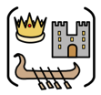
Year Five – History: Do invasions always result in change?
 | Sticky knowledge
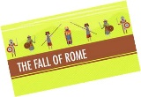 | A – The Roman Empire ended in 410 AD and was in turmoil across Europe. It had broken into 2 (East and West). Consequently, Roman military leaders abandoned Britain so that they could defend Rome against Germanic tribes. This led to change in Britain.
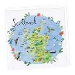 | B - To keep the Scots out of England the Romans built Hadrian’s wall in AD 122. According to historical enquiry, the Scots, from Ireland invaded North Britain in 410 AD where the Picts lived. As a result, this became known as Scotland
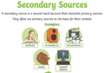 | C - Secondary sources often include asking questions about primary sources to interpret the past. Accurate interpretation is based on the reliability of a source.
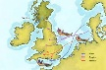 | D – As a consequence of the Romans leaving, Britain was easier to invade. Anglo-Saxons ruled from 410AD – 1066AD, they were a mix of tribes from Germany, Denmark and The Netherlands.
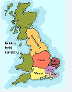 | E - The Anglo-Saxon word for town in “burh” and many towns today still have this as part of their name – Edinburgh. When the Anglo-Saxons first settled in Britain, there were seven kingdoms - Northumbria, Mercia, East Anglia, Wessex, Essex, Sussex, Kent but by AD 878 there was just one kingdom left. They called the land Eagle Land which became known as England.
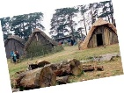 | F - Anglo Saxons invaded from the East and built settlements near rivers and coasts for food and farming. Anglo Saxons lived in family houses which were built using wood and straw around a central hall where the village chief lived.
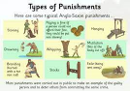 | G - The Anglo-Saxon were originally Pagens and superstitious. The had many Gods but adopted Christianity and many churches were built by the Anglo Saxons. They created the first laws in Britain, some are very similar to what we have today.
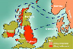 | H- The Vikings came from the modern Scandinavian countries of Denmark, Norway and Sweden. They first invaded Lindisfarne in AD793.
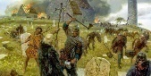 | I The Vikings raided places such as monasteries to steal gold and pillaged expensive items to trade. They took inhabitants to use as slaves. They invaded and settled in Scotland before heading south to places such as York. By AD 878 the Vikings had settled permanently in Britain. They failed to rule over the kingdom of Wessex.
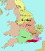  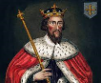 | J- Alfred the Great prevented England from falling to the Vikings, he defeated the Vikings at the Battle of Edington. He negotiated peace with the Danish leader Guthrum, which allowed some continuity for the Saxons. He promoted learning and literacy, he introduced defense measures, reformed the law and the use of coinage
 | K- By 884 a treaty was agreed that left Vikings ruling over Danelaw in the North of England. This was where the laws of the Danes dominated the Saxon laws. Danelaw ended when King Athelstan drove the Vikings out.
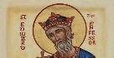 | L- Edward the Confessor was known for his religious faith; therefore he was called the Confessor. His life was characterised by piety and religious belief, he was the last but one of the Anglo Saxon Kings of England
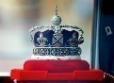 | M- Both the Roman and Viking invasions were significant as they have shaped our nation today and some of our ways of life. The monarchy in England (and the UK) is still in place now, although its powers have changed and have been absorbed by central government. We no longer believe in the divine right of kings
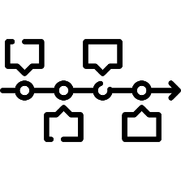
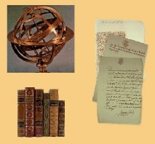
Exciting texts!
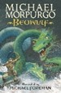
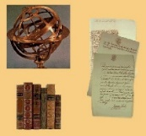
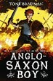
Reliable sources
Timeline

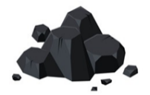
Sticky Knowledge
DT
N) Your design must meet the specification in the design criteria, for your audience. If a design meets all the design criteria for a particular audience, it should appeal to them .
O) 3D drawings can be annotated with the dimensions (measurements) of the product and show how it will look in real life from different perspectives. Annotations are notes and labels which record opinions, functionality or design which enable the designer to follow a plan.
P) Prototype is a draft version of a product (a practise run). Prototypes are used to ensure the design will fully meet the design criteria. Final version – the finished product.
Q) Competently means knowing how to do something successfully. Working safely means taking precautions to minimise risk of injury to yourself.
R) Evaluating a product against the design criteria means checking that it fully meets each criterion.

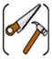


Sticky Knowledge
Geography
S) Italy is located in Europe in the northern hemisphere.

