Subject Specific Vocabulary
debug | Finding errors in given instructions.
logic | Using sensible, step-by-step rules to solve a problem.
trace | Reading and analysing code.
generalisation | A way of quickly solving new problems based on previous problems we have solved.
simulated environment | A virtual space created to imitate real-world activities.
virtual world | A computer-simulated environment which may be populated by many users at once.
variable | A labelled box in a computer that holds a piece of information, such as a number or a name.
prediction | A logical guess on what will happen.


Year Four – Computing – Coding
 | Sticky knowledge
 | Programs need planning based on a desired outcome  A simulated environment is a virtual world, which can be altered
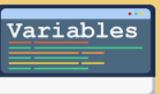 | Variables change an outcome
 | Reading code step-by-step allows you to spot errors (debug)  Correcting errors allows a program to work
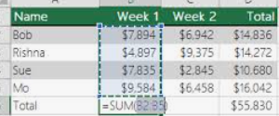 | Some programs are more suitable and appropriate to achieve a goal (Excel used for data, rather than word)
 | Websites enable the use of a range of content  Different software can be used to achieve different goals (e.g. paint to edit a photo)  Content can then be incorporated and linked in a presentation
 | A prediction is logical guess on what will happen
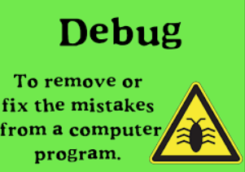 | Debug (find errors) in given instructions  Debugging involves fixing problems by going through line by line


