Subject Specific Vocabulary
circuit | A pathway that electricity can flow around. It includes wires and a power supply and may include bulbs, switches or buzzers.
electricity | The flow of an electric current through a material, e.g. from a power source through wires to an appliance.
generate | To make or produce.
renewable | A source of electricity that will not run out. These include solar, geothermal, hydro and wind.
non-renewable | This source of energy will eventually run out and so will no longer be able to be used to make electricity. These include fossil fuels – coal, oil and natural gas.
appliances | A piece of equipment or a device designed to perform a particular job, such as a washing machine or mobile phone.
battery | A device that stores electrical energy as a chemical.
 |  | Sticky knowledge
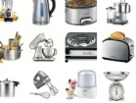 |  | Electrical appliances can run on mains electricity or batteries and smaller appliances can be moved from place to place.
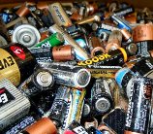 | Batteries eventually run down and need to be replaced or recharged.
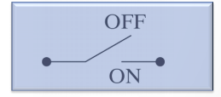 | Switches are used to turn circuits on and off.
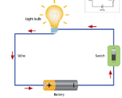 | Circuits have components and wires which the electricity can flow around.
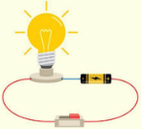 | Electricity can only travel if there is a complete circuit.
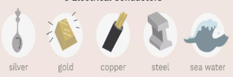 | Some materials are electrical conductors allow electricity to pass through them. For example, metals like copper, silver and gold.
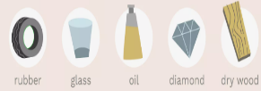 | Some materials are electrical insulators do not allow electricity to pass through them. For example, such as wood, plastic, glass and rubber.
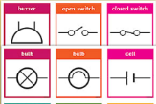 | Circuit diagrams use symbols instead of pictures.
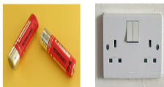 | Some appliances run on battery, mains or both.

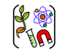
Aspirational Scientist:
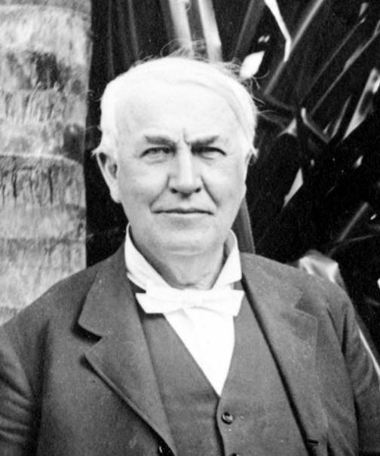
Thomas Edison inventor of a light that did not need oils or gas to be lit. Edison created a lightbulb that would stay lit using electricity
for 13 ½ hours!
Year Four – Electricity
Working Scientifically
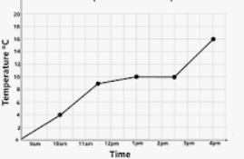
Observation Recording

