
Year Four – MFL: My Home
 | Sticky knowledge
 | Can have a short conversation of 3 or 4 exchanges  Begin to use pronouns when responding to questions
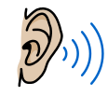 | Listen for cues to answer and ask own questions.
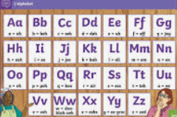 | Children use phonics and alphabet knowledge of TL to show improving confidence to asking and answering a range of questions in the target language.
 | Recall simple vocabulary such as colours, parts of the body, animals and, with practice and support, begin to use this vocabulary to build simple sentences orally with the support of a speaking frame.  Form the negative to give answers to simple questions about likes/dislikes e.g. I don’t like ….  Use a wider range of verbs to express opinion such as love, hate, adore, detest.  Recognise, say and spell simple letters/letter strings associated with justifying opinions  Form sentences verbally by selecting words from a word bank or speaking frame.
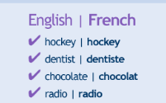 | Identify cognates and familiar language in a text and use them to work out context and infer meaning.
Use phonic knowledge in TL to accurately say and spell new words in TL.
Remembering exceptions and silent letters.
Subject Specific Vocabulary
Ou habites-tu? | Where do you live?
J’habite dans… | I live in..
Une maison | A house / home
Un appartement | An apartment
En ville | City
À la campagne | In the countryside
À la montagne | In the mountains
Au bord de la mer | At the seaside
Dans un village | In a village

