Subject Specific Vocabulary
scale | A set of notes arranged in order from low to high, or high to low.
solo | When one person or instrument plays a piece of music all by themselves.
ensemble | A group of musicians, like a band or orchestra, who play together.
accompaniment | The music that supports a main melody, like when a singer has a piano or band playing along with them.
stave | A set of five horizontal lines and the four spaces between them, used like a ladder to write and read music.
notehead | The part of a note, whose placement on the staff indicates the pitch.
tail | The end of a piece of music
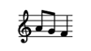
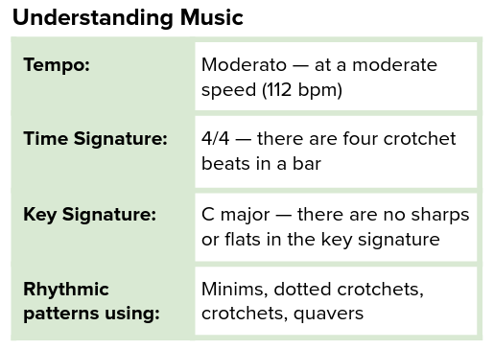

 | Sticky knowledge
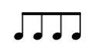 | Changing the tempo of a performance can make it sound more exciting (faster) or calmer (slower). Varying the dynamics during a performance can make it sound more interesting. Changing the timbre of your voice can help to illustrate the meaning of the lyrics.
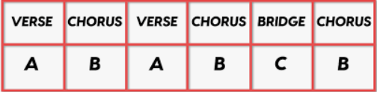 | Structure is how the music is put together into different sections.
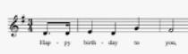  Year Four – Music: How does music improve our world?  How does music shape our way of life? | Melodies ascend, descend, leap and have repeated notes.  Memorising songs can help us to sing more fluently and with expression.  Practising songs, little and often, can help you to sing fluently and from memory.
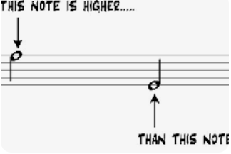 | We can find out how high or low to play by looking at the position of the note on the stave. We can find out how long or short a note is by looking at the colour of the notehead, and whether it has a stick and/or tail.
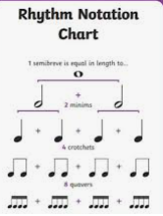 | Notes can be placed higher and lower on the stave, using both the lines and spaces, to show when the pitches ascend and descend. Rhythm is shown by the colour of the notehead, and whether it has a stick and/or tail and whether they are joined together.
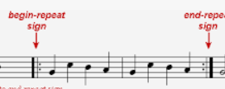 | Spotting repetition and contrasts can make it quicker and simpler to learn a piece of music. Practising doesn’t always mean going from the start sometimes it means repeating just one section or phrase until you get it right.
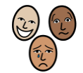 | A piece of music can be performed in different ways to change its mood.  Music can be placed into categories such as time periods, genre, style or tradition.



