
Year Four– PE: Dodgeball and Hockey
 | Sticky knowledge
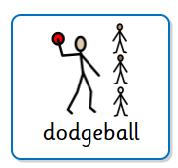 | Dodgeball
 | Throwing and catching accurately allows you to keep possession and score.
 | Some throws include: chest-pass, shoulder-pass, over-head pass, bounce-pass, pop-pass.
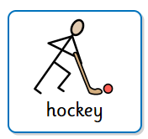 | Hockey
 | Striking can include rackets, bats, club, hands.
 | Good striking requires good hand-eye co-ordination.
 | Ready position is important.
 | Grip is important.
 | Preparation for shot is important.
 | Motion of striking/ swing is important.
 | Follow-through is important for direction.
 | Body position and position of equipment in relation to object being struck is important.
Subject Specific Vocabulary
throwing | Using your arm and hand to send something through the air, like a ball.
catching | Using your hands to grab something moving through the air, like a ball.
possession | Physical control of the ball or other implement of play by one team.
passing | An intentional transfer of the ball from one player to another of the same team.

Subject Specific Vocabulary
opposition | The other team.
striking | Making contact with a stationary or moving object with the aim of propelling that object towards a desired target or area.
follow through | The movement of the arm or leg after you hit, kick, or throw a ball, completing the motion instead of stopping immediately.
coordination | The ability to use their body parts together smoothly and efficiently to perform a movement.

