
Year Four– PE: Dance and Orienteering
 | Sticky knowledge
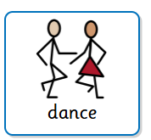 | Dance  A theme is an idea or topic, for example: history topic such as The Greeks,  animals such as cat. This acts as a stimulus.
Communication through dance involves showing ideas through actions,
sequences and patterns.
 | Leading means guiding others.
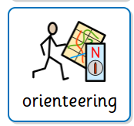 | Orienteering
Demanding means more challenging - physically, technically, strategically
More demanding could include a larger area to find different objects using clues.
 | A time limit is the amount of time allowed to complete a course.
 | Strategy is a planned set of actions to achieve a goal (what).
 | Tactics carefully planned set of actions (how).
 | To mark a map successfully, orientating and identifying landmarks is required.
 | Describing position in relation to landmarks is important to identifying location.
Subject Specific Vocabulary
stimulus | Stimulus is something that causes a response.
choreographing | Choreographing is designing movement patterns to perform.
leading | Leading means to guide others.
theme | An idea or topic.

Subject Specific Vocabulary

strategy | Laying down the goals and making a plan to get there.
tactics | The little decisions you make in the moment, based on the rules and what your teammates and opponents are doing.
orientation | Knowing where you are – identifying it on a map.
physically | Relating to the body as opposed to the mind.
technically | The technique used in a sport.
strategically | To think carefully with a plan to achieve a goal.

