

Year Four – PSHE: Friendships, Families and Mental Health.
 | Sticky knowledge
 | Healthy friendships make people feel included. When people feel lonely I can help include them by talking to them, sharing what they like doing to find common interests.
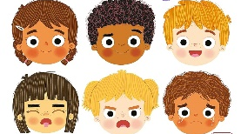 | Feelings can change over time in range and intensity. This can be due to changes in circumstances. These feelings can be positive or negative and change over time.
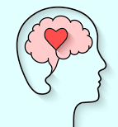 | Mental Health affects how we think, feel, and act. It also helps determine how we handle stress, relate to others, and make healthy choices.
 | Spending time with family and friends can support mental health and wellbeing.
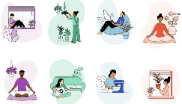 | Strategies and behaviours to support my mental health include; good quality sleep, physical exercise/time outdoors, being involved in community groups, doing things for others, clubs, activities and hobbies.
 | People who love and care for each other can be in a committed relationship (e.g. marriage), living together, but may also live apart.
Subject Specific Vocabulary
mental health | Mental health includes our emotional, psychological, and social well-being. It affects how we think, feel, and act.
emotional wellbeing | Emotional wellness is the ability to successfully handle life's stresses and adapt to change and difficult times.
feelings | An emotional state or reaction to something.
emotions | A strong feeling you get from your mood, circumstance or relationship with others. E.G. Angry, upset, anxious, joy.
positive  relationship | Healthy relationships involve honesty, trust, respect and open communication between partners and they take effort and compromise from both people.
committed  relationship | A long term emotional relationship.

