Subject Specific Vocabulary
ancient | Something from a very long time ago.
civilisation | A human society with well-developed rules and government, often where technology and the arts are considered important.
Egypt | The country on the continent of Africa where the Ancient Egyptian civilisation was created.
hieroglyphics | A system of writing that consists of pictures and symbols (hieroglyphs) instead of letters.
pharaoh | A ruler of Ancient Egypt.
tomb | A sealed room where a person was placed after death.
gods/goddesses | The Ancient Egyptians worshipped many gods and goddesses who were responsible for different aspects of life and death.
Celts | People living in Britain in tribes, including the Iceni, Brigantes and Catuvellauni..
citizen | A person with all the rights and protections of a nation or land. In the Roman Empire, only citizens were able to vote.
conquest | Taking control of a place by force, often with an army.
emperor | The ruler of an empire.
empire | A group of countries controlled by one ruler (emperor or empress) or government.
Roman Empire | The name used for the land that was controlled by the Romans, including large parts of Europe plus parts of North Africa and West Asia.
rebellion | An uprising or revolt by people who want to challenge what they believe is unfair treatment by rulers.
 | Sticky knowledge
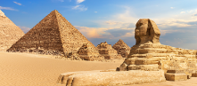 | The earliest records of an Ancient Egyptian society appeared in 3150BC to 30BC.
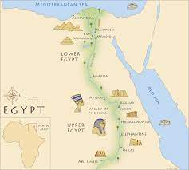 | Ancient Egyptian civilisation was located along the River Nile in NE Africa and Thebes was the ancient capital.
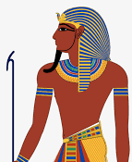 | The pharaoh was the leader of Egyptian religion and society as a whole. They were seen as a demi-god and had absolute power.
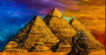 | The Ancient Egyptians developed monumental pyramids, temples and obelisks.
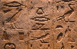 | The Ancient Egyptians developed an effective system of medicine and a comprehension system of communication (hieroglyphs).
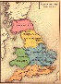 | The first Roman invasion of Britain was in 42AD and ruled for around 400 years.
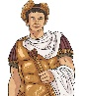 | In 43AD Emperor Claudius launched the 3rd and final invasion of Britain.
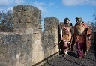 | Hadrian’s Wall was built to mark the boundaries of the Roman Empire and to keep the Scots out.
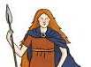 | Boudicca was the joint ruler of the Iceni tribe and led the Iceni tribe into battle against Roman forces.
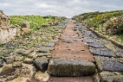 | The Roman occupation: advanced technology (e.g. Transport and road construction), materials and metals were used for armour and weaponry, brought Christianity and introduced sanitation.

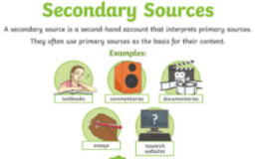
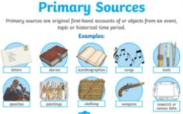
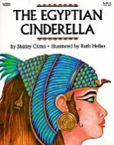
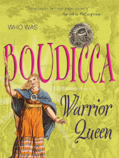
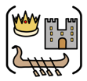

Enhancer Sticky Knowledge
- A sculpture is three-dimensional art made by one of four basic processes: carving, modelling, casting, constructing.
- There are a number of joining techniques that can be used: Fold, Insert, Slot and Wrap.
- Tools are used to add finer detail to sculptures.
- Ancient Egyptian art includes paintings, sculptures, drawings on papyrus, jewellery, ivories, architecture, and other art media.
- The Ancient Egyptians often depicted pharaohs in their artwork.
- The Egyptians are famous for their giant works of sculptures. Some examples of this include the Great Sphinx of Giza and the statues of Ramses II at the Abu Simbel temples.
- Art can be used as a historical source.
Primary and Secondary sources can help us to find out information
Year Four – History: What can we learn from what has been left behind?
Exciting texts!

