
Year Four – RE: Why do some people think that life is like a journey and what significant experiences mark this?
 | Sticky knowledge
 | A pilgrimage is a spiritual journey.
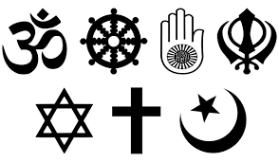 | There are reasons behind the ritual of pilgrimage linked to each religion.
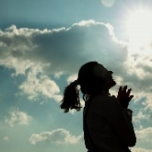 | Belonging to a community and being spiritual can help deepen a person’s faith.
 | Music, stories, memories and rituals are part of the experience for believers taking part in pilgrimage.
 | People who are non-religious may make their own spiritual journey e.g Stonehenge.
Subject Specific Vocabulary
pilgrim | A person who journeys to a sacred place for religious or spiritual reasons.
pilgrimage | A pilgrimage is a spiritual journey.
ritual | A set of actions or words performed in a regular way.
journey | An act of travelling from one place to another.
spiritual | Relating to people’s thoughts and beliefs.
Varanasi | A place of pilgrimage for Hindus.
Mecca | A place of pilgrimage for Muslims.
Holy Land | A place of pilgrimage for Christians.
Muslim | A follower of the religion of Islam.
Christian | A follower of the religion of Christianity.
Hindu | A follower of the religion of Hinduism.

Key Belief:
A pilgrimage is a spiritual journey e.g. Muslim journey to Mecca, Hindu journey to Varanasi, Christian journey to the Holy Land.



