Subject Specific Vocabulary
vibrate | To move back and forth very quickly and repeatedly.
ear drum | The membrane of the middle ear, which vibrates in response to sound waves.
vacuum | A space with very little or no matter, like air.
transmit | To cause (something) to pass on from one person or place to another.
pitch | How high or low a sound is.
insulation | To use a special material to stop sound from getting through.
volume | How loud or quiet the sound is.
 |  | Sticky knowledge
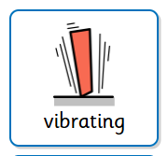 |  | Sound happens when something vibrates. It is not always obvious what is vibrating to make a noise (e.g., air in a bottle). We hear sound when vibrating air hits our ear drums and makes them vibrate. Vibrations in ear drums are transmitted to our brains.
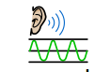 | Sounds are vibrations which are transmitted through air or another medium A vibrating object makes the air or medium, such as liquids and solids, next to it vibrate as well.
 | Sounds cannot travel through a vacuum because there is nothing to transmit the vibrations
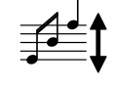 | The pitch of a sound is how high or low a note is.
 | Vibrations with lots of energy make loud sounds. Vibrations with little energy make quiet sounds. The harder you hit something, the louder the noise. The softer you hit something, the quieter the sound.
 | Volume decreases when you get further away from the source of the sound. Volume increases when you get closer to the source of the sound. Sound vibrations lose energy as they travel further and further. If something is making a lot of noise, but it is far way, it sounds quiet.
 | Insulation of a sound makes it quieter.


Working Scientifically
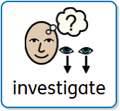
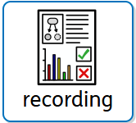
Aspirational Scientist:

Galileo was one of the first people to study how sounds are made. He found out that the pitch of a sound (how high or low it is) depends on how often something vibrates. To show this, he scraped a metal tool called a chisel across a metal plate. When he moved the chisel faster, the scratches were closer together, and the sound was higher. When he moved it slower, the scratches were further apart, and the sound was lower.

Year Four – Sound

