Subject Specific Vocabulary
credibility | How much you can trust a source or information.
cross-referencing | Checking information in more than one place to see if it matches.
filters | Make searches more specific.
sources | Can be primary or secondary.
refine | Changing your search to make it more specific and helpful.
relevant | Connected to what you are learning or looking for.
audience | The people something is made for.
analysing | Looking at something carefully to understand it better.
evaluating | Judging how good, useful, or trustworthy something is.
presenting | Sharing ideas or information with other people.


Year Six – Computing – Networks / Search Engines/ Using Programs
 | Sticky knowledge
 | Internet is a network of computers that the WWW works on.
 | World Wide Web are the pages that you see when you’re online.
 | Searches can provide quality content, as well as poor content.
 | Cross-referencing allows you compare and check the credibility of information.
 | Filters make searches more specific.
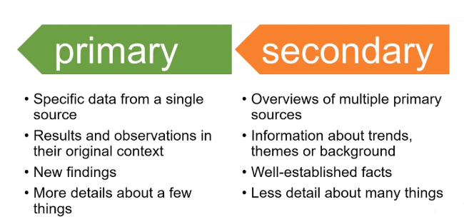 | Sources can be primary or secondary.
 | Media files such as audio and video files can be embedded in PowerPoint presentations.
 | Online content can be embedded in Word and PowerPoint files (i.e. YouTube videos).
 | PowerPoint allows us to present information in a clear way.  Word allows us to record information.  Excel allows us to record data.
 | PM Busy Beats allows us to create and play music.  PM 2Code allows us to develop programs.  PM 2Paint allows us to design and create images Publisher allows to create leaflets, posters and reports.
 | Younger children require easy to read and understand content.  Older children need something to engage them and stimulate their imagination.  Adults need more detailed content that is relevant.


