 | Sticky knowledge
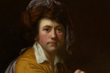 | Joseph Wright was a Derbyshire born artist, known for his portraits and English landscapes. He linked elements of Romanticism with powerful images of science and technology. His depictions of artificial light on the faces of experimenters and their audiences captured the sense of wonder.
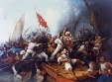 | Romanticism is an 18th century movement in the arts and literature that emphasized nature, imagination, emotion, and the individual.
 | In art, different tools, techniques and materials can be combined for a range of purposes, strength and aesthetics.
 | Sketchbooks are used to design, edit and evaluate the effectiveness of a piece of artwork.
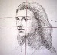 | The term perspective refers to the representation of objects in three-dimensional space (i.e. for representing the visible world) on the two-dimensional surface of a picture.
 | Self-critique is a personal analysis of work in a detailed way. Peer-critique is the detailed analysis of work carried out by a peer.
Subject Specific Vocabulary
legacy | The long-lasting impact of particular events or actions that took place in the past, or in a person’s life.
showmen | A person who produces or presents shows as a profession.
Showmen’s Guild | The leading Trade Association for the Travelling Fairground Industry.
culture | The ideas, customs, and social behaviour of a particular people or society.
critique | A detailed analysis and assessment of something.
community | A group of people living in the same place, or having a particular characteristic in common, sharing or having certain attitudes and interests.
influential | To have an effect on ideas , opinions or thoughts.
Joseph Wright | An English landscape and portrait painter.
tenebrism | A style of painting that shows dark tones and shadows with contrasting effects of light.


Year Six – Enquiry: Are we a product of our heritage?
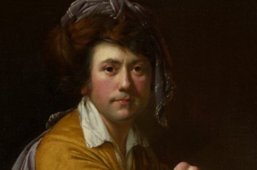
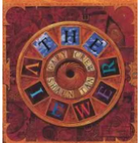

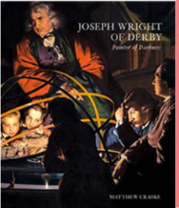

Joseph Wright

Born: 3 September 1734
Died: 29 August 1797
Exciting texts!

Enhancer Sticky Knowledge
 |   Sticky knowledge
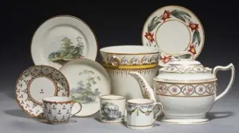 | Pinxton Porcelain was a porcelain works created by John Coke and William Billingsley in Pinxton in Derbyshire in 1796. Pinxton Porcelain is known for producing floral tableware (teacups, saucers, teapots).
 | Showmen travel the country setting up fairs, including rides, games and eateries. The Showmen’s Guild was set up in 1899 to protect their interests. It still exists today and has grown to have nearly 5000 members.


Sticky knowledge

 | Culture is the ideas, customs and social behaviour of a particular people or society.
 | Society is a group of people living together in a community.
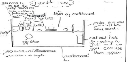 | A cross-sectional diagram shows the inside of products. To make a product stronger and stiffer it should be reinforced with a strong structure, joins and with denser, thicker materials.
 | Evaluations involve looking back at the experience of designing and making something and considering what went well, what they would change and how it meets the design criteria.

