Subject Specific Vocabulary
competence | Having the necessary ability, knowledge, or skill to do something successfully.
articulate | Explaining the rules to others improves communication and understanding of games.
teamwork | Working together with others to succeed in a game or activity.
fair play | Playing by the rules and treating everyone with respect.
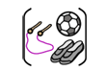

Year Six – PE – Indoor: Handball and Dodgeball

 | Sticky knowledge
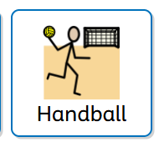 | Explaining rules helps teammates and opposition to play fair.
 | Competency is using a skill effectively in a range of sport.
 | Good teamwork includes: turn-taking, sharing responsibility, taking leadership and co-operating.
 | Explaining rules helps to reinforce understanding.

Subject Specific Vocabulary
personal best | The best time or score ever achieved by a sports player in a particular event.
self-reflection | Thinking about what you do, how you feel, and why you do things.
communication | Communication in PE means sharing information clearly so that everyone can work together safely and successfully.
endurance | The ability of the body to perform physical activity for a sustained period.
leadership | Leading involves good communication, sound knowledge and understanding of the game situation.
physical wellbeing | Being healthy and strong by taking care of your body.
mental wellbeing | How you feel, think, and act, which affects your emotional, psychological, and social health.

 | Sticky knowledge
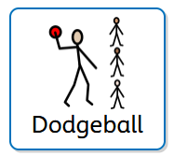 | Exercise contributes to physical wellbeing.  Exercise contributes to mental wellbeing
 | Sharing ideas can help the performance of others and themselves.
 | Communication involves sharing thoughts and feelings.
 | Leading is demonstrating effective decisions for the game being played for example: before kick-off, choosing a tactic, formation, substitutions.



