
Year Six – What will change as we become more independent?
How do friendships change as we grow?

 | Sticky knowledge
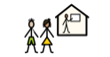 | Strategies to manage transition and change include being organised, planning ahead, talking to friends/family, making a map.
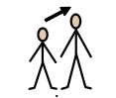 | Growing up allows the chance to take on new responsibilities and we can be more independent.
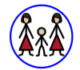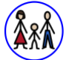 | There are different types of families, but all have families share the same characteristics of commitment, care and spending time together. If a family relationship or friendship makes me feel unhappy or unsafe, I can speak to a trusted adult or ChildLine.
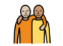 | Friendships can change over time due to changes in personality, likes/dislikes and making new friends.
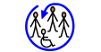 | Everyone is different including their personality, background, appearance etc and we must treat everybody with the same respect regardless of this.
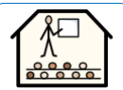 | There are a variety of routes I can take after finishing secondary school: college, university, apprenticeship, work.
Subject Specific Vocabulary
transition | A period of changing from one state or condition to another.
responsibilities | Having a duty to deal with something or of having control over something.
independence | Not depending on another.
family | A group of two or more persons related by birth, marriage, or adoption.
career | An occupation undertaken for a significant period of a person's life and with opportunities for progress.
apprenticeship | Learning a trade from a skilled employer having agreed to work for a fixed period.
college | An educational institution or establishment, that provides higher education or specialised professional training.
university | A higher level educational institution or establishment.

Year Six – What will change as we become more independent? How do friendships change as we grow?

 | Sticky knowledge
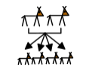 | As part of the human life cycle, humans reproduce. This happens when the female sex cell: the egg is released from the ovary and fertilised by the male sex cell: sperm.
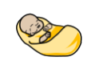 | Babies are born through the vagina or can be born through a caesarean section.
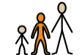 | I can talk to adults in school or at home about growing, changing and puberty.
 | Everyone is different including their personality, background, appearance etc and we must treat everybody with the same respect regardless of this.
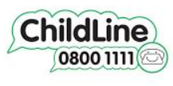 | There are different types of families, but all have families share the same characteristics of commitment, care and spending time together. If a family relationship or friendship makes me feel unhappy or unsafe, I can speak to a trusted adult or ChildLine.
Subject Specific Vocabulary
Reproduction | The action or process of copying something.
Human life cycle | Six main stages of life: foetus, baby. Child, adolescent, adult and elderly.
puberty | The period during which adolescents reach maturity and become capable of reproduction.
egg | Single cell released from the female reproductive organs.
sex cells | Sperm produced by men and egg cells are produced by women.
ovaries | A female reproductive organ in which eggs are produced.
uterus | The hollow organ in a woman's pelvis. where a fetus (unborn baby) develops and grows. Also called womb.
testicles | Either of the two oval organs that produce sperm in men and other male mammals, enclosed in the scrotum behind the penis.
fertilisation | The action or process of fertilising an egg or a female animal or plant, involving the fusion of male and female.

