

Year Six – RE: What matters most to Christians and Humanists?
 | Sticky knowledge
 | Humanists believe that you can be good without God.
 | Humanists follow the rules - Be Honest/ Use your mind/ Tell the truth/ Do to other people what you would like them to do to you.
 | As a Christian, you should strive to live a life full of peace, faith, joy and goodness.
 | Christians should also practice generosity, honesty, respect, faith, patience, self-discipline, and courage.
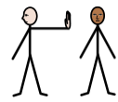 | Racism can harm individuals by making them feel excluded, unsafe, or less valued – it ruins communities by creating division and unfairness.
 | Many religions teach that all people are equal and deserve respect — for example, Christianity teaches that everyone is made “in the image of God,” and Islam teaches that people are equal before Allah.
 | By practising fairness, respect, and compassion, people can challenge racism and help build stronger, kinder communities — for example, Martin Luther King Jr. used Christian teachings of justice and love to stand against racism.
Subject Specific Vocabulary
Charity | An organization set up to provide help and raise money for those in need.
Ahimsa | The respect for all living things and avoidance of violence towards others (harmlessness).
agape | A choice, a deliberate striving for another’s highest good, and is demonstrated through action.
Agnostic | A person who believes that nothing is known or can be known of the existence or nature of God.
Ummah | The whole community of Muslims bound together by ties of religion.
Atheist | A person who disbelieves or lacks belief in the existence of God or gods.
justice | The quality of being fair and reasonable.
faith | The strong belief of a religion.
racism | Treating someone unfairly because of their skin colour, race, or cultural background.
inclusion | Making sure everyone feels welcome and able to take part.
prejudice | Judging someone before you know them, often based on stereotypes.

Key Belief:

Humanists believe that you can be good without God.
.

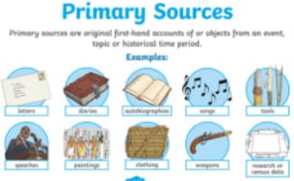
Primary and Secondary sources can help us to find out information

