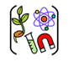

Aspirational Scientist:
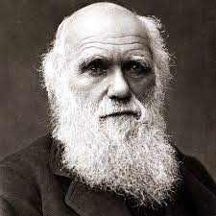
Charles Darwin was an English scientist who studied nature. He is known for his theory of evolution by natural selection. According to this theory, all living things are struggling to survive. The living things that have the most helpful traits for their environment tend to survive. These living things then pass along their helpful traits to their young. In this way, animals change, or evolve, over hundreds of years. He described his ideas in his important book, On the Origin of Species by Means of Natural Selection (1859).
Year 6 – Evolution and Inheritance
 | Sticky knowledge
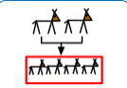 | Animals that survive longer, have more offspring (babies).  Offspring inherit (get) features from their parents (Therefore offspring are well-adapted to their habitat).
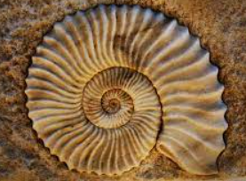 | Fossils show how living things have changed How living things change over time is called evolution.  Fossils show us how plants and animals used to look (possibly even millions of years ago).
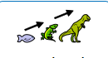 | The plants and animals that were around millions of years ago looked different to plants and animals that are around today – this is because living things have changed over time – they’ve evolved.
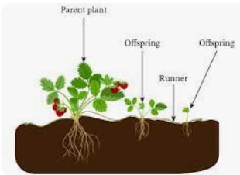 | Animals and plants produce offspring (babies) that are similar to them. Animals and plants have some features that are different to their parents and each other.
 | Offspring look like their parents because parents pass on characteristics (features) to the offspring. Offspring look like their parents because they inherit some features from their parents
 | Humans can live all over the world. We can do this because we are able to wear clothes and build houses suited to different conditions – like the heat of the desert or the cold of the Arctic. Most plants and animals can only live in certain environments.
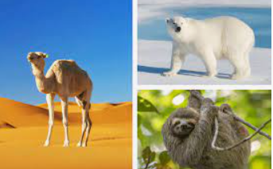 | Habitats give living things food and shelter. Animals and plants are adapted to their habitat. To help them survive in their habitat, living things can develop special features (adaptations) to suit the place they live. Over time, more and more of the animals (or plants) will end up with features that make them well-adapted to their habitat.
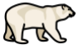 | Surviving hot environments. Deserts can reach temperatures in excess of 55 degrees C – animals have adapted to live in deserts successfully. Surviving cold environments – the Poles are very cold – animals have adapted to live in the extreme cold. All living things go through changes during their lifetimes.
Subject Specific Vocabulary
evolution | Evolution is the way that living things change over time.
vary | To differ in size, amount or nature from something else.
adapted / adaptation | To make (something) suitable for a new use or purpose; modify.
inherit | To receive a feature from your parents.
fossils | The remains or impression of a prehistoric plant or animal embedded in rock and preserved in petrified form.
variation | The heritable differences within a species.
offspring | A person’s child or children.
characteristics | A feature or quality belonging typically to a person, place, or thing and serving to identify them.
Working Scientifically


Primary and Secondary sources can help us to find out information

