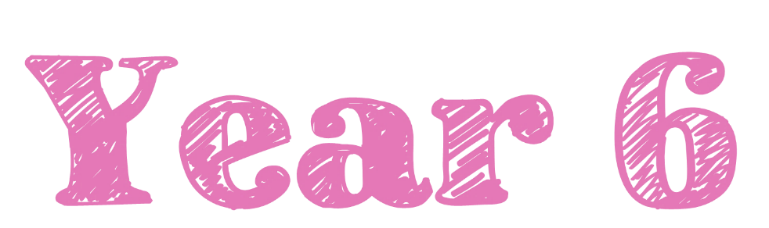  Summer Term 2026 |  | 
Welcome to Year 6!

We hope you have all had a super Easter break and are feeling well rested and ready for our final, extremely busy term!

As a reminder, healthy snacks (such as fruit or cereal bars) are allowed in school for break times.
If you have any concerns, please don’t hesitate to come and talk to us.

Miss Bentley and Miss Oakley

Reading Diaries and Books  Your child will regularly read their book in class and we will look at their diaries every week.  PLEASE make sure your child brings their book and diary to school every day. Please read with your child every day and sign their diary to show this. It is incredibly important that you list to your child read every day. If you would like support with listening to your child read at home, please speak to Miss Bentley or Miss Oakley.  Children will receive a reading book at the start of this term. We will assess them on these books regularly to make sure they have the right book for them. If you are worried that these books are too easy or too challenging, please speak to your child’s teacher. | PE Kits  On PE days, children will need to come to school in their PE kits. Children will be unable to join in with PE lessons, if they are not wearing their kit.  On PE days, please make sure earrings are removed and hair is tied up.  Miss Bentley’s PE days will be Mondays and Fridays  Miss Oakley’s PE days will be Mondays and Fridays  Please make sure footwear is appropriate for running around and that you don’t mind if they get muddy and wet. Inhalers must be in school on these days too.
Important Dates | Homework  Children are expected to read at home and practise their times tables (on TT Rockstars) daily.  Children are expected to continue to work on their SATS buster books weekly up until their SATS.  TT logins can be found in the back of your child’s home school diary
  Event | Dates
  Bank Holiday | Monday 4th May
  KS2 SATS Week | Mon 11th May – Thurs 14TH May
  Parent’s Residential Meeting | Thurs 21st May
  INSET DAY | Fri 22nd May
  Y6 Residential | Mon 15th June – Wed 17th June
  Class Photographs | Mon 22nd June
  Sports Day | Wed 1st July
  Reserve Sports Day | Thurs 2nd July
  Pupil Conference | Tues 7th July
  Y6 production | Tues14th July 2pm and 6pm
  Frederick Gents Transition Day | Wed 15th July all day
  Attendance Fun Day | Tues 21st July
  Y6 leaver’s assembly | Thurs 23rd July 10.00am

Follow us on social media, where we showcase our wonderful school and learning experiences.

This term, our enquiry focusses on our heritage in our community, school and locally. In particular, we will be looking at the artwork of Joseph Wright, a local Derbyshire artist and celebrating our local community through the design of fairground games and creating our own Pinxton pottery. Our Hook Day will immerse children in the enquiry from the first day where we will be exploring different mediums and portraits.
Are we a product of our heritage?
Deepening Knowledge Tasks

Reading  Reading is the gateway to the curriculum. We will be reading the text The Final Year.  In lessons, we are focusing on the skills of presenting understanding and inference  When you read with your child, please ask them questions about what they have read so they can demonstrate their understanding.  The Viewer - Shaun Tan (youtube.com)  An Introduction to The Final Year with Matt Goodfellow - YouTube  Below is a website to support with SATS revision  KS2 English - BBC Bitesize | Writing  This term we will be writing a narrative based on the story The Viewer. We will also be writing a newspaper report on the discovery of Pinxton Porcelain and a biography of Joseph Wright.  To prepare even more, perhaps you could begin to research Pinxton Porcelain  The Viewer - Shaun Tan (youtube.com)  Joseph Wright of Derby Facts for Kids (kiddle.co)  Below are some websites to support with SATS revision  KS2 English - BBC Bitesize  Grammar - KS2 English - BBC Bitesize |  | Maths  We follow the White Rose scheme in Maths. Follow the link below and you can follow lesson by lesson what your child is learning in school.  https://whiterosemaths.com/homelearning/year-6/ Summer  This is a great resource to support your child and for you to see how we teach maths.  Below are some websites to support with SATS revision  KS2 Maths - BBC Bitesize  Y6 Arithmetic Practice - Mathsframe
Science

In science, our focus will be biology and we will be learning about evolution and inheritance.
This will cover the history of evolution, key discoveries and adaptation of species.
To develop your learning at home, research the different theories of evolution. How do they compare?
Further support for science can be found here: https://classroom.thenational.academy/units/humans-and-animals-over-time-db18

RE  We follow the Derbyshire Syllabus. This term, we will be learning around the questions:  - What difference does it make to believe in ahimsa (harmlessness), grace and/or Ummah (community)?  - What matters most to humanists and creationists?  AHIMSA - Find out WHAT Inspired GANDHI to take Non -violence path! Animal stories | KIDS Moral story (youtube.com)  The impact of non-violence (For Kids in English) (youtube.com) |  | PSHE  We teach PSHE through the PSHE Association. This term we will be focusing on the questions:  - What will change as we become more independent?  - How do friendships change as we grow?  This will include our relationship and sex education programme. More details of this will follow in the summer term.  KS2 PSHE: Balancing new and long standing relationships - BBC Teach
Computing  We teach Computing through Purple Mash. This term we will be learning about blogging and networks.  Online Safety is still paramount. The following links may help you with reminders to keep safe:  https://school-learningzone.co.uk/key_stage_two/ks2_computing/ks2_e_safety_for_kids.html  https://www.saferinternet.org.uk/advice-centre/young-people/resources-3-11s  https://www.nspcc.org.uk/keeping-children-safe/online-safety/ |  | PE  In PE, there will be a variety of indoor and outdoor sports, including handball, rounders, dodgeball and athletics  Primary School PE- How to Play Handball (youtube.com)  How to play dodgeball | Games for kids (youtube.com)



