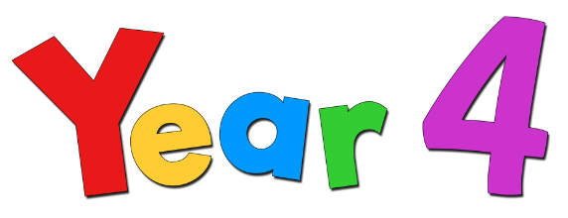  Summer Term 2026 |  | 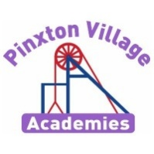
Year 4 Newsletter
Welcome back!
We hope you all had a relaxing Easter holiday and are recharged for the Summer Term. We are looking forward to having you back with this us and continuing our adventure in Year 4! We have lots of exciting things happening and fun filled days planned to include our Graffiti Workshop, Gullivers Residential and Sports Day!

Remember, if you have any concerns, please don’t hesitate to come and talk to us.

Year 4 Team
Mrs Donald and Miss Brooks
Reading Diaries and Books  Your child will regularly read their book in class and we will look at their diaries every day.  PLEASE make sure your child brings their book and diary to school every day.  Please read with your child every day and sign their diary to show this as it’s important that children get the opportunity to read. To help support your child’s reading progress please listen for your child pronouncing words correctly and ask questions about the books they are reading. Discussing stories will help your child talk about what they have read and help you to highlight ideas/words they might not have understand. | PE Kits  Our PE days this term continue to be Tuesdays and Mondays.  On PE days, children will need to come to school in their PE kits. Children will be unable to join in with PE lessons, if they are not wearing their kit.  Please make sure footwear is appropriate for running around and that you don’t mind if they get muddy and wet. Inhalers must be in school on these days too, as well as long hair being tied back and earrings out to avoid injury.
Important Dates | Homework  Children are expected to read and practise their times tables (on TT Rockstars) daily. TT logins can be found in the back of your child’s home school diary.  By the end of Year 4, children are expected to know and recall all of times tables which will be tested in June. To support this, please help your child to practise their times tables using TT Rockstars. Songs are also a catchy method for your child to learn their timetables.  White Rose Maths videos are also shared in Class Dojo every week with the week’s learning and these need to be watched each day.
  Event | Dates
  Return to school | 13th April
  Hook Day Artist in school | 13th April
  Bank Holiday | 4th May
  LCH Colour Run | 21st May
  Half Term | 22nd – 31st May
  Return to school | 1st June
  Class Photographs | 22nd June
  Y4 Residential | 7th – 8th July
  Sports Day | 1st July
  Reserve Sports Day | 2nd July
  Pupil Conference | 7th July
  Attendance Fun Day | 21st July
  Last day of Summer term | 23rd July

Follow us on social media, where we showcase our wonderful school and learning experiences.

Is it better Is it better to create than destroy?

This term, our enquiry question is: Is it better to create than destroy? This is an art-based enquiry. The children will develop an understanding of the importance of artist perspective and messages. Throughout the term, we will be learning about Banksy and how their work of graffiti has developed. We will also be developing our sketching skills.

On the next page is a knowledge organiser showing everything we will learn this term about Banksy and the art skills we will be developing. To support us with our learning, James Mayle (aka riot68 http://www.riot68.com/ ) from iMAGESKOOL, will be running an exciting Graffiti Workshop for Y4.

Deepening Knowledge Task
Your home learning challenge to deepen your understanding:
Reading | Writing |  | Maths
Reading is the gateway to the curriculum. We will be reading the text The Tin Forest.  In Summer term 1 we are concentrating on inferential understanding in which we use clues to interpret what an author is implying through use of vocabulary.  In Summer term 2, we are concentrating on reading to find out in which we will develop our questioning skills and retrieval skills to locate key information from texts.  When you read with your child, please ask them questions about what they have read so they can demonstrate their understanding.  Here are some links to key text we will be reading this term:  The Tin Forest - https://www.youtube.com/watch?v=_j_XPFxy5js  So, this is Love? - https://www.youtube.com/watch?v=KuyvNi5ytaQ | This term we will be writing a narrative based on the story The Tin Forest. We will also be studying Banksy through our enquiry and writing a non-chronological report based on the artist.  We will be exploring and writing our own poems.  Complete some extra research on Banksy to support your writing.  Tin Forest:  https://www.youtube.com/watch?v=_j_XPFxy5js  Banksy Graffiti walls and wasn’t sorry:  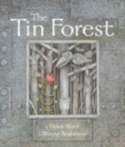  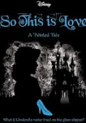  https://www.youtube.com/watch?v=fhYGpQgbM04 |  | We follow the White Rose scheme in Maths.  Follow the link below and you can follow lesson by lesson what your child is learning in school.  https://whiterosemaths.com/homelearning/year-4/
Science
In Summer, we will be learning about Living things and their habitats and Animals, including humans. The children study classification of animals; learn about digestion and teeth and construct food chains.
The following links will support our science learning:
https://classroom.thenational.academy/units/human-anatomy-f968 https://classroom.thenational.academy/units/ecosystems-0008
RE  We follow the Derbyshire Syllabus. This term, we will be learning:Why are festivals important to religious communities?  Why do some people think that life is like a​ journey and what significant experiences mark this?  https://www.bbc.co.uk/bitesize/topics/z24kqyc |  | PSHE  We teach PSHE through the PSHE Association. This term we will be focusing on the question:  How can our choices make a difference to others and the environment?  https://classroom.thenational.academy/units/yes-its-our-world-our-wonderful-world-887a
Computing  We teach Computing through Purple Mash. This term we will be learning about effective searching.  Please follow the links to support with online safety. https://www.nspcc.org.uk/keeping-children-safe/online- safety/ |  | PE  Outdoor PE this term is tennis and cricket. Indoor PE this term is athletics and competitive athletics  https://classroom.thenational.academy/units/athletic-activity-run-jump-and-throw-1-4b0c  https://classroom.thenational.academy/units/gymnastics-activity-sequencing-d5e7

 | Sticky knowledge
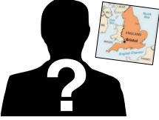 | Banksy is an England-based street artist, political activist and film director whose real name and identity remain unconfirmed and the subject of speculation. This graffiti uses a distinctive stencilling technique. In October 2018, one of Banksy's works, Balloon Girl, was sold in an auction at Sotheby's in London for £1.04m. However, shortly after the gavel dropped and it was sold, an alarm sounded inside of the picture frame and the canvas passed through a shredder hidden within the frame, partially shredding the picture, this increased it’s value to £2 million.
 | Bob and Roberta Smith (Patrick Brill) trained as a sign painter in New York and uses text as an art form, creating colourful slogans on banners and placards that challenge elitism and advocate the importance of creativity in politics and education.
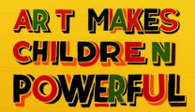 | Slogan art is art that uses slogans (phrases of text) more than pictures- but some pictures can be included. Slogans are phrases or sayings that promote something, such as a brand, an event, a cause… For example: Black lives Matters , Tesco – “Every little helps.”
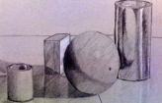 | Proportion is an element of art that compares the size of a part of an object in relation to the size of another part of the same objects and scale is the overall size of the art produced.
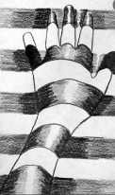 | Depth refers to the perceived distance between the background and the foreground of a composition. Depth can be created through shading and the development of techniques e.g. hatching, cross hatching, smudging and accent lines.
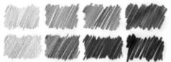 | The tone of something refers to how light or dark it is. Areas with lots of light are called highlights, and darker areas are called shadows. There are a range of tones in between.
Subject Specific Vocabulary
graffiti | Graffiti is art that is written, painted or drawn on a wall or other surface, usually without permission and within public view.
street artist | A street artist is a person who makes art in public places.
political activist | A political activist person who believes strongly in political or social change and takes part in activities to try to make this happen.
stencilling | Stencilling is a technique for reproducing designs by passing ink or paint over holes cut in cardboard or metal onto the surface to be decorated.
Dismaland | Dismaland was a temporary art project organised by street artist Banksy in the seaside resort of Weston-Super-Mare in Somerset, England.
accent lines | Accent lines are lines which creates emphasis on a part of an artistic design.
shading | Shading is the process of adding value to create the illusion of form, space, and most importantly - light in a drawing.
hatching /  cross hatching | Hatching is when the lines all go the same way, cross hatching when they go in 2 or more opposite directions.





- Mood boards are used to gather ideas. They are a place for inspiration to be recorded.
- Lights and switches can be used to enhance a product.
- Sewing is using thread to join or mend materials.
Exciting texts!
Year Four – Enquiry: Is it better to create or destroy?
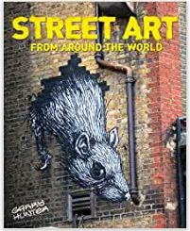
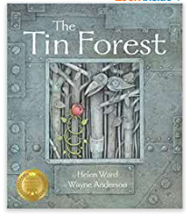
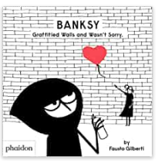
Primary and Secondary sources can help us to find out information

