Subject Specific Vocabulary
culture | Beliefs and behaviours that are traditionally practiced by a group of people.
stippling | Drawing of several small dots to create a picture.
cross hatching | A shading technique that uses lines that cross over each other.
sculpture | Art in 3D.
influential | A thing or person that has the power to affect another.
carving | A design that has been cut out of a material.
casting | An object made by pouring molten metal or other material into a mould.
sculptor | An artist who creates art in 3D.
modelling | The working of materials by hand.
replicate | To repeat, replicate, copy or reproduce.
refine | The improvement of an idea.
competently | Have sufficient skills, knowledge or experience to do something well.
perspective | An art technique for creating an illusion of 3- dimensions on a 2 -dimensional surface.
form | The illusion of a 3- dimensional object.
constructing | A sculpture built of many parts.
 | Sticky knowledge
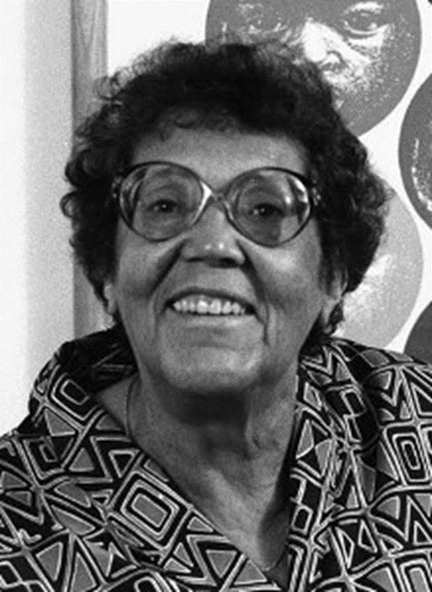 | Elizabeth Catlett is an African American born printmaker and sculptor who is famous for her prints and sculptures of black people. Her artwork was inspired by the causes and consequences of racism and feminism.
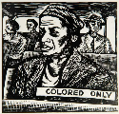 | Elizabeth Catlett’s work explores and appreciates “black people in their beauty and dignity for ourselves and others to understand and enjoy.”
 | Elizabeth Catlett’s sculptures are created using different techniques yet have similar themes such as: students aspire, mother and child, magic mask and the singing head.
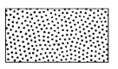 | Stippling is the process of drawing or painting using numerous dots or specks. More dots causes darker areas and fewer dots are used for lighter areas.
 | Bridget Riley is an English artist who began creating ‘Op art’ in the 1960’s. Op artists put colours, shapes and patterns together in clever ways to create an optical illusion. When exploring and appreciating ‘Op art’, the patterns and shapes can make an image look like its moving and can be interpreted in different ways.
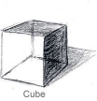 | Form is a 3-dimensional shape like a cube, cone or pyramid. The term is usually applied to sculpture, although artists can use tone and perspective to create the illusion of form in two-dimensional artwork.
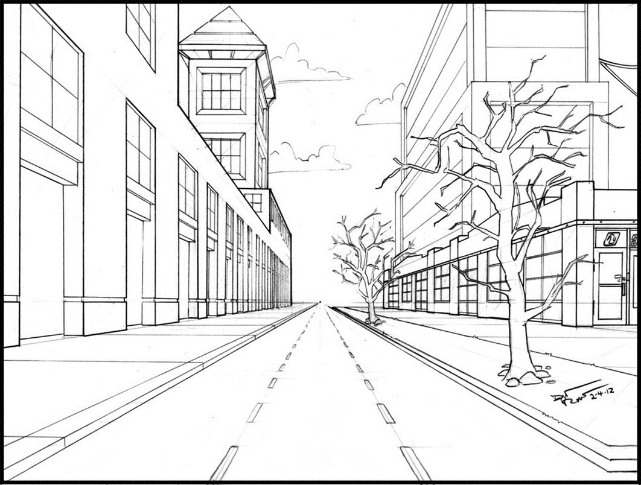 | Perspective is an art technique for creating an illusion of depth or 3 dimensions on a 2- dimensional surface
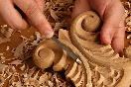 | Carving is the cutting of material to produce a form or figure.
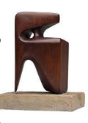 | A sculpture is an art form made in 3 dimensions. Sculptors use four basic processes – carving, modelling, casting and constructing. There are similarities and differences in each process.


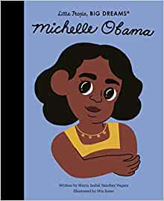


Exciting texts!
Year Five – Art: How does art change perspectives and opinions?


 | DT Sticky Knowledge
 | CAD is computer aided design - CAD is used for investigating, designing and editing designs on the computer. It is able to imitate what the product would look like in real life.
 | Information about existing products may be analysed, considering: appearance, function, price, size or other elements.


 | PSHE Sticky Knowledge
 | Respect means that you accept someone for who they are, even when they are different from you or you don’t agree with them.
 | Respect is caring enough to consider how words and actions impact ourselves and others.

