Subject Specific Vocabulary
harmony | When two or more parts are sung or played together.
partner songs | Can be sung or played by themselves or together.
dynamics | The loudness and softness within a piece of music.
texture | Different parts playing at the same time.
melody | The melody is the main tune.
interval | The difference between notes in a piece of music.
balance | Being aware of all of the elements of music, not just one part.
octave | The music interval made up of 8 notes
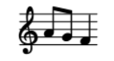

Year Five – Music: How does music teach us about our community?
 | Sticky knowledge
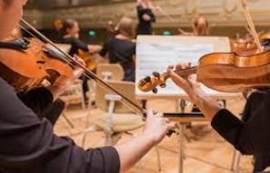 | Partner songs are songs which can be sung on their own or combined together and performed at the same time to make a new piece of music.
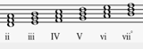 | The distance between individual notes in a melody or harmony is called an interval (2nd, 3rd, 4th, 5th, 6th, 7th, 8th or octave)
 | It is important to justify why we think a piece of music is successful or unsuccessful using musical vocabulary.
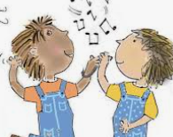 | Improvising means to make something up on the spot.
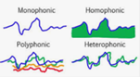 | The overall mood and effect of a composition is decided by the way that the inter-related dimensions of music are used together.
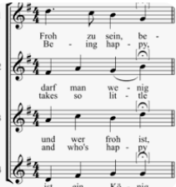 | Elements of music can be used to contrast different works. These include mood, instrumentation, complexity, or use of musical motifs. These differences provide character to each piece of music.




