Subject Specific Vocabulary
exercise | Physical activity that you do to improve or maintain your fitness and health.
physical wellbeing | Being healthy and strong by taking care of your body.
mental wellbeing | How you feel, think, and act, which affects your emotional, psychological, and social health.
resilience | The ability to keep trying and not give up when a physical activity is difficult or when you face setbacks.
endurance | The ability of the body to perform physical activity for a sustained period.
endorphins | Endorphins are hormones that can make us feel happier.
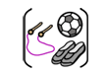

Year Five – PE – Indoor: Health Related Fitness and Dance

 | Sticky knowledge
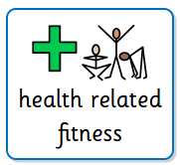 | Keeping active will improve the components of fitness.
 | Exercise can release endorphins.
 | Components of fitness include: agility, balance, coordination, strength, flexibility, stamina, speed, power.
 | Keeping active can help improve mental wellbeing.
 | The ability of the body to perform physical activity for a sustained period is called endurance.
 | Health related fitness helps you stay healthy and feel good.

 | Sticky knowledge
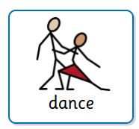 | Clarity is how clearly a movement or action is performed.
 | Fluency is moving with flow and purpose.
 | Accuracy is moving with precision to perform a desired movement.
 | Consistency is the ability to repeat movements and/or skills repeatedly with fluency, control and success.
 | Accompaniment is something alongside to contribute to a dance, for example: music, video, instrument or voice.
 | Composing is to create an organised dance with choreography.
Subject Specific Vocabulary
self-reflection | Thinking about how well you performed and how you can improve.
performance | How well you carry out a physical activity or skill.
improvement | Getting better at a skill through practice.
precision | Performing a skill accurately and correctly



