Subject Specific Vocabulary
athletics | Sports that include running, jumping, and throwing.
optimal | The best way to do something for the best result.
force | A push or pull that makes something move.
speed | How fast you can move.
distance | How far you go or throw something.
athletic ability | How good you are at physical activities or sports.
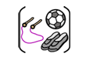

Year Six – PE – Outdoor: Athletics and Cricket

 | Sticky knowledge
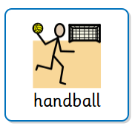 | Approach is the movement before take-off.
 | Take off is leaving the ground to start the jump.
 | Landing is returning to the ground with control.
 | Effective jumping requires combining a good approach, take-off and landing.
 | Long jump – 1 foot to 2 feet. Hurdling- 1 foot to alternate foot, run, repeat.
 | Different throws produce different distances The optimal angle of release is 45 degrees for furthest distance.

Subject Specific Vocabulary
collaboration | Working together with teammates to achieve a goal.
executing | Doing a skill or plan correctly, like hitting a shot or catching a ball.
backswing | The backward movement of the bat before hitting the ball.
anticipating | Predicting what the ball or opponent will do next.
tactics | A plan or strategy to win or play better.
intercepting | Stopping or catching the ball before it reaches the opponent.
 | Sticky knowledge
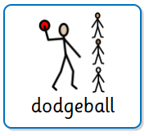 | Cross bat (hook) shot: Move the forward leg from 12 to 9 on a clock face to be straight on. Move your back foot outside off stump onto the ball of your foot Take the hands high in the backswing allowing you to hit from high to low.
 | Extend the hands out and strike the ball with a horizontal sweep of the bat (the key is to fully extend the arm of your bottom hand - the pull is a bottom hand stroke)
 | Pivot on the ball of your back foot and hit the ball at arms-length for maximum power Roll the wrists to keep the ball down. Executing a desired shot can outwit an opponent and have a tactical advantage
 | Attacking batting: Sideways onto the ball. Bat held in two hands on the handle. Large draw back quick explosive release in a straight line towards the ball. Take a positive stride forwards.



