 | Sticky knowledge
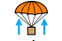 | Air resistance is a force caused by air that slows down objects as they move through it.
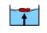 | Water resistance is a force caused by fluids which slows down objects as they move through it.
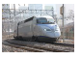 | To travel faster through the air or water, things need to be streamlined.
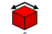 | To travel slower through the air or water, you need a large surface area.
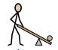 | A lever is a simple mechanism made from a long pole and a pivot.  If you push with a small force on the long side of the lever, you produce a bigger force on the short side.
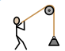 | A pulley is a rope running over a wheel which acts to change the direction of a force.
 | Gears are wheels with teeth that fit together.  The two wheels turn in opposite directions.  If the wheels have different numbers of teeth, the second wheel will turn at a different speed to the first one.
 | Water resistance is often called drag.
 | It’s easier to lift the object by pulling down on the rope than picking it up.
Subject Specific Vocabulary
causal relationship | A relationship (correlation) between two events where one causes the other to happen.
air resistance | A kind of friction that occurs between air and another object.
friction | A force between two surfaces that are sliding across each other.
water resistance | A type of force that uses friction to slow things down in water.
streamlined | An object that is shaped to travel through air or water with as little resistance as possible.
mechanism | Devices that we create to help us.
pivot | The point around which an object can rotate or turn.
refute | To refute means to prove a theory wrong.
comparative test | Comparative testing is where you would test several different materials or object and compare the differences or similarities.
surface area | The surface area of a solid object is a measure of the total area that the surface of the object occupies.
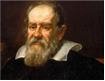
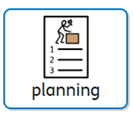
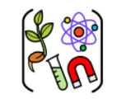

Aspirational Scientist:

Galileo Galilei was an Italian scientist who formulated the basic law of falling bodies, which he verified by careful measurements. He constructed a telescope with which he studied lunar craters and discovered four moons revolving around Jupiter and espoused the Copernican cause.
Working Scientifically
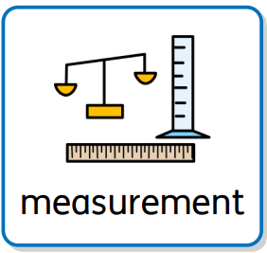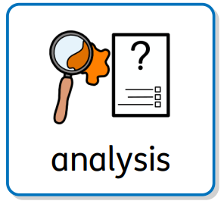
Year Five – Forces

