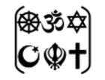

Year Five – RE: what does it mean to be a Muslim in Britain today?
 | Sticky knowledge
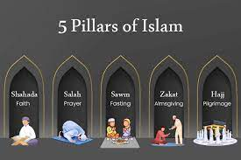 | The 5 pillars of Islam are: Shahadah: faith, Salat: performing prayers in the proper way five times each day, Zakat: charity, Sawm: fasting during the month of Ramadan, Hajj: pilgrimage to Mecca
 | Fasting helps Muslims to appreciate how poor people suffer. It also concentrates the mind on what it means to be a Muslim and obey the command of Allah. It helps to build discipline into the life of a Muslim.
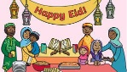 | The festival of Eid-ul-Fitr happens at the end of Ramadan. It is a day of celebration, happiness and forgiveness.
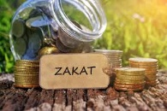 | Zakat, is a way in which Muslims help and care for the world-wide Muslim community (Ummah).
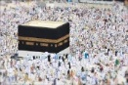 | Muslims believe that hajj is only compulsory when they have enough money and can provide for their family whilst they are away.
 | In Christianity, churches run projects such as Eco Church, where they save energy, recycle, and create wildlife-friendly churchyards.
 | In Islam, mosques may organise clean-up events in their local area and teach that wasting water, even when washing for prayer, is wrong.
 | In Hinduism, festivals like Diwali and Ganesh Chaturthi are becoming more eco-friendly, for example by using clay idols instead of plastic ones to protect rivers.
 | In Buddhism, many monks and communities plant trees — in Thailand, some even ordain trees as monks to stop them from being cut down.
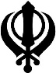 | Sikh gurdwaras often serve langar (free meals) using locally grown or vegetarian food to reduce harm to the environment.
Subject Specific Vocabulary
Shahadah | The first of the 5 pillars meaning ‘faith.’
Salat | The second of the 5 pillars meaning- to perform prayers in the proper way 5 times each day.
Zakat | Charity.
Sawm | Fasting during the month of Ramadan.
Hajj | Pilgrimage to Mecca.
Allah | The Arabic word used by Muslims for God.
prophet | Someone who speaks on behalf of a God.
Mecca | A city in Saudi Arabia that was the birthplace of Mohammed.
pilgrimage | A sacred journey undertaken for spiritual purposes.
prayer | An act of worship that is like a conversation with your God.
Islam | The faith followed by Muslims.


Key Belief:
The five pillars are the core beliefs and practises of Islam.

Key Belief:
Muslims believe there is only one God whose name in the Arabic language is Allah.

