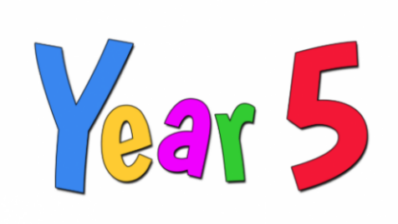Summer Term 2026 |  | 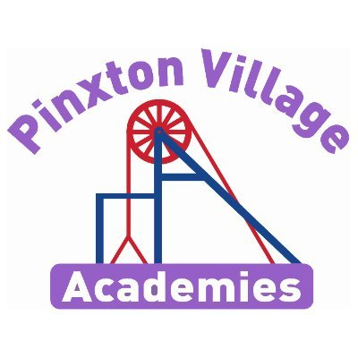
Year 5 Newsletter
Welcome back!

We hope you all had a great Easter break. We cannot believe that we are now in our final term. We have another great term ahead of us that we know you’re going to love!
As a reminder, healthy snacks (such as fruit or cereal bars) are allowed in school for break times.
Remember, if you have any concerns, please don’t hesitate to come and talk to us.
Year 5 Team:
Mr Dickson and Mr Maycock

Reading Diaries and Books  Your child will regularly read their book in class and we will look at their diaries every day.  PLEASE make sure your child brings their book and diary to school every day.  Please also try and read with your child every day and sign their organiser to say they have read every day.  If you need any support with reading at home with your child, please don’t hesitate to contact us. When you read with your child, please ask them questions about what they have read so they can demonstrate their understanding.  Your child will regularly read their book in class and will record any spellings and reading to an adult in their diaries. | PE Kits  Our PE days this term are Wednesdays and Fridays.  On PE days, children will need to come to school in their PE kits. Children will be unable to join in with PE lessons, if they are not wearing their kit.  Please make sure footwear is appropriate for running around and that you don’t mind if they get muddy and wet. Inhalers must be in school on these days too, as well as long hair being tied back and earrings out to avoid injury.
Important Dates | Homework  Children are expected to read at home and practise their times tables (on TT Rockstars) daily.  TT logins can be found in the back of your child’s home school diary  White Rose Maths videos are also shared in Class Dojo every week with the week’s learning so your child can watch them daily before the lesson. They can also use these videos after the lesson to secure their learning of a particular objective.
  Event | Dates
  Return to school | 13th April
  Enquiry hook day | 13th April
  Colour run | 21st April
  Bank Holiday | 4th May
  INSET Day | 22nd May
  Half Term | 23rd May
  Class photos | 22nd June
  Sports Day | 1st July
  Pupil Conference | 7th July
  Reserve sports day. | 2nd July
  Attendance fun day | 21st July
  Last day | 23rd July

How does art change perspectives and opinions?

This term our enquiry question is ‘How does art change perspectives and opinions?’ This is an art and design based enquiry that will focus on the work of the printmaker and sculptor Elizabeth Catlett and the Op artist Bridget Riley. Through the creative arts children will have the opportunity to deepen their understanding for other cultures and experiences from around the world. They will have challenging conversations about what they perceive is morally wrong and right, with art as a stimulus.
Deepening Knowledge Task
Your home learning challenge to deepen your understanding:
Reading  Reading is the gateway to the curriculum. We will be reading the text Slave Girl by Patricia C McKissackby and focusing on the skills of inference and reading to find out. When you read with your child, please ask them questions about what they have read so they can demonstrate their understanding. Click on the link to read about Harriet Tubman who escaped slavery and fought to save others too. https://nowpressplay.co.uk/ks2-harriet-tubman-black-history-month-blog/  Follow this link to read ‘Amazing Grace’ by Mary Hoffman. https://fliphtml5.com/ikenx/oqrj/basic | Writing  This term we will be writing biography on Elizabeth Catlett and a balanced argument entitled Slavery – right or wrong?  Research slavery and create a bank of words and phrases and points for and against that you can use in your balanced argument.  Here are some links to help you:  https://kids.kiddle.co/Elizabeth_Catlett#:~:text=Elizabeth%20Catlett%2C%20born%20as%20Alice,focused%20on%20the%20female%20experience.  https://kids.britannica.com/kids/article/slavery/353782 |  | Maths  We follow the White Rose scheme in Maths. Follow the link below and you can follow lesson by lesson what your child is learning in school. https://whiterosemaths.com/homelearning/year-5/  All children also have a Times Tables Rockstars login in their Home School Diary. This is a great way to keep practising times tables.
Science
In science, our focus will be Physics and we will be learning about Forces. We will learn about air resistance, water resistance and friction. Using our knowledge of gears, levers and pulleys, we will design a product for a purpose.

The following link will provide further learning in this area:
https://classroom.thenational.academy/units/forces-717d

RE  We follow the Derbyshire Syllabus. This term, our key question is:  What does it mean to be a Muslim in Britain today?  Follow the link for more information:  https://www.bbc.co.uk/bitesize/articles/zrxxgwx |  | PSHE  This term, we will be focusing on economic well being through the questions:  What impact does money have on us?  What jobs would we like?  Follow the link to try some different activities that can help children to understand money and budgeting.  https://natwest.mymoneysense.com/students/students-8-12/
Computing  We teach Computing through Purple Mash. This term we will be learning about word processing and concept maps.  We also teach how to stay safe online in our computing lesson. The following links maybe helpful:  https://www.childnet.com/young-people/4-11-year-olds/  https://www.nspcc.org.uk/keeping-children-safe/online-safety/ |  | PE  In PE, there will be a variety of indoor and outdoor sports.  Indoor we will be focussed on Dance and Health Related Exercise. Outdoor we will be focusing on cricket and athletics.  Indoor:  https://www.thenational.academy/pupils/programmes/physical-education-primary-year-5-l/units/dance-activity-making-and-mixing-the-main-elements-of-dance-1f06/lessons  Outdoor:  https://www.thenational.academy/pupils/programmes/physical-education-primary-year-5-l/units/athletic-activity-run-jump-and-throw-2-2c34/lessons

 | Sticky knowledge
 | Respect means that you accept someone for who they are, even when they are different from you or you don’t agree with them. Respect is caring enough to consider how words and actions impact ourselves and others.
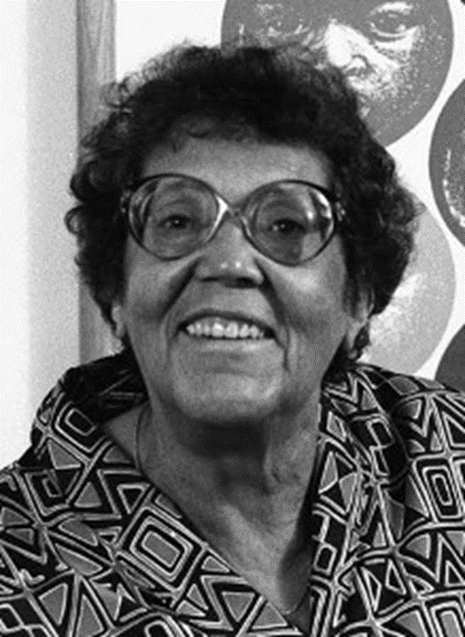 | Elizabeth Catlett is an African American born printmaker and sculptor who is famous for her prints and sculptures of black people. Her artwork was inspired by the causes and consequences of racism and feminism.
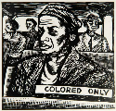 | Elizabeth Catlett’s work explores and appreciates “black people in their beauty and dignity for ourselves and others to understand and enjoy.”
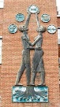 | Elizabeth Catlett’s sculptures are created using different techniques yet have similar themes such as: students aspire, mother and child, magic mask and the singing head.
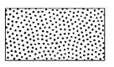 | Stippling is the process of drawing or painting using numerous dots or specks. More dots causes darker areas and fewer dots are used for lighter areas.
 | Bridget Riley is an English artist who began creating ‘Op art’ in the 1960’s. Op artists put colours, shapes and patterns together in clever ways to create an optical illusion. When exploring and appreciating ‘Op art’, the patterns and shapes can make an image look like its moving and can be interpreted in different ways.
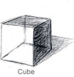 | Form is a 3-dimensional shape like a cube, cone or pyramid. The term is usually applied to sculpture, although artists can use tone and perspective to create the illusion of form in two-dimensional artwork.
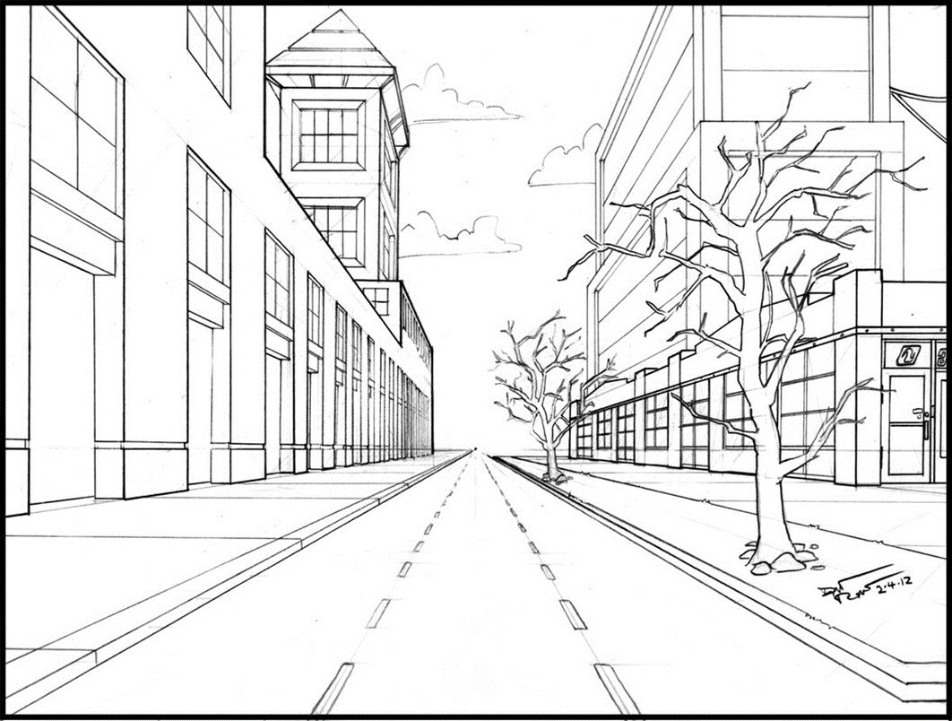 | Perspective is an art technique for creating an illusion of depth or 3 dimensions on a 2- dimensional surface
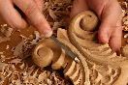 | Carving is the cutting of material to produce a form or figure.
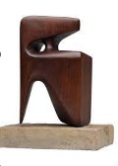 | A sculpture is an art form made in 3 dimensions. Sculptors use four basic processes – carving, modelling, casting and constructing. There are similarities and differences in each process.
Subject Specific Vocabulary
culture | Beliefs and behaviours that are traditionally practiced by a group of people.
stippling | Drawing of several small dots to create a picture.
cross hatching | A shading technique that uses lines that cross over each other.
sculpture | Art in 3D.
influential | A thing or person that has the power to affect another.
carving | A design that has been cut out of a material.
casting | An object made by pouring molten metal or other material into a mould.
sculptor | An artist who creates art in 3D.
modelling | The working of materials by hand.
replicate | To repeat, replicate, copy or reproduce.
refine | The improvement of an idea.
competently | Have sufficient skills, knowledge or experience to do something well.
perspective | An art technique for creating an illusion of 3- dimensions on a 2 -dimensional surface.
form | The illusion of a 3- dimensional object.
constructing | A sculpture built of many parts.

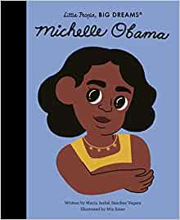
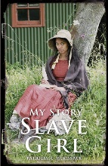

Year Five – Art: How does art change perspectives and opinions?
Exciting texts!



Sticky Knowledge
DT

CAD is computer aided design - CAD is used for investigating, designing and editing designs on the computer. It is able to imitate what the product would look like in real life.

Information about existing products may be analysed, considering: appearance, function, price, size or other elements.
PSHE

A Respect means that you accept someone for who they are, even when they are different from you or you don’t agree with them.

Respect is caring enough to consider how words and actions impact ourselves and others.



