  Autumn Term 2026 |  | 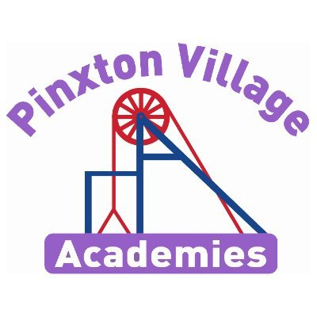
Welcome back!

We hope you all had an amazing summer. We are really looking forward to getting to know you all this term as we start our Year 5 journey together. We have lots of exciting things happening this year that we know you’re going to love!
As a reminder, healthy snacks such as fruit or cereal bars are allowed in school for break times.
Please, if you have any concerns, don’t hesitate to come and talk to us.

Miss Oakley and Mr Maycock

Reading Diaries and Books  Your child will regularly read their book in class, and we will look at their diaries every Friday.  Please make sure your child brings their book and diary to school every day. Please also try and read with your child every day and sign their organiser to say they have read.  If you need any support with reading at home with your child, please don’t hesitate to contact us. When you read with your child, please ask them questions about what they have read so they can demonstrate their understanding.  Your child will regularly read their book in class and will record any homework, spelling and reading to an adult in their diaries. | PE Kits  Children will need to come to school in their PE kits on the days they have PE.  PE days are:  Wednesday and Friday  Children will be unable to join in with the sports coach if PE kits are not in school.  On PE days, please make sure earrings are removed and hair is tied up.  Swimming will start in January. More information about this will be sent out nearer the time.
Important Dates | Homework  Children are expected to read, practise their spellings and practise their times tables (on TT Rockstars) daily.  This homework is compulsory and is designed to build on the learning we do in school.  TT logins can be found in the back of your child’s home school diary  White Rose Maths videos are also shared in Class Dojo every week with the week’s learning.
  Event | Dates
  Hook Day | 4th September
  Aspiration Day | 2nd October
  Parents evening | 6th and 7th October
  Junior Halloween Disco | 21st October
  Yorkshire Wildlife Park | 4th November
  Children in Need | 20th November
  Wear Pink Day | 23rd November
  Christmas Fair | 2nd December
  Carol concert | 16th December

Follow us on social media, where we showcase our wonderful school and learning experiences.

Am I Too Small To Make A Difference?

This term our enquiry question is ‘Am I Too Small To Make A Difference?’ This is a geography based enquiry, in which we want to broaden our children’s horizons to in still higher aspirations for the world. We want to develop a sense perspective and understanding of how their own lives impact on the world. Building on their learning of the local context and how they fit into the wider world community. Throughout the term, we will be learning about the similarities and differences of Brazil compared to Britain; about the Amazon Rainforest; the impact of deforestation and how we can make a difference. To support us with our learning we will be visiting Yorkshire Wildlife Park.
Deepening Knowledge Task

Reading  Reading is the gateway to the curriculum. We will be reading the text The Explorers by Katherine Rundell and focusing on the skills of reading to understand.  Here is an extract from ‘The Explorer’ for you to read together at home.  https://www.booktrust.org.uk/globalassets/resources/blogs/2017/september/the-explorer-katherine-rundell-extract.pdf  Comprehension texts will be sent home each week for your child to complete. | Writing  This term we will be writing our own Rainforest narrative based on The Explorers. We will then be writing a non-chronological report about Brazil.  Research the rainforest and create a bank of descriptive words and phrases that you can use in your narrative and non-chronological report.  Here are some links to help you:  https://kids.nationalgeographic.com/geography/countries/article/brazil  https://www.kids-world-travel-guide.com/brazil-facts.html |  | Maths  We follow the White Rose scheme in Maths. Follow the link below and you can follow lesson by lesson what your child is learning in school. Maths home learning | Home learning | White Rose Education  This is a great resource to support your child and for you to see how we teach maths. Every week, video links to the lessons will be posted on Dojo.
Science
In science, our focus will be Biology and we will be learning about Animals including Humans. To develop your learning at home, use the following link will provide further learning in this area.
https://classroom.thenational.academy/units/reproductive-cycles-d195
RE  We follow the Derbyshire Syllabus. This term, we will be learning about why some people believe God exists.  The following link will help you develop your learning at home.  https://www.bbc.co.uk/bitesize/topics/ztkxpv4/articles/zvfnkmn |  | PSHE  This term we will be focusing on the question:  What makes up our identity? We would look at our differences and the importance of mutual respect, linking to British Values.  Our PSHE curriculum is supported by the PSHE Association  Further support can be found here:  Unit - Oak National Academy (thenational.academy)  If you would like to talk through any of the curriculum planning and resources for this term, please contact your child’s class teacher.
Computing  We teach Computing through Purple Mash. This term we will be learning about how to stay safe online. The following links maybe helpful  https://www.saferinternet.org.uk/advice-centre/young-people/resources-3-11s  https://www.nspcc.org.uk/keeping-children-safe/online-safety/ |  | PE  In PE we will be learning the skills of basketball and Tag Rugby (outdoors) and gymnastics and dance (indoors)  Here are some tip tips:  https://www.youtube.com/watch?v=xVvVdJcrgZU  https://www.youtube.com/watch?v=cjrFEOooe7g  Physical education, primary, Year 5 - Lesson listing | Oak National Academy (thenational.academy)  We will also be swimming this year. This will start in January and more information will be sent out in the autumn term.



