Subject Specific Vocabulary
variable | Help to develop a code.
organise | To arrange things in an orderly way, or to make plans for something to happen.
tabs | Tabs organise a program into separate pages.
interpret | Understand the meaning of something in a way that makes sense to others.
action | Something that is done for a particular purpose.
reliable | You can count on it to work or behave as expected, without failing.
 | Sticky knowledge
 | Variables can develop code (e.g. timers and score counters using conditional statements e.g. if the timer reaches 0, the game ends). String variable is a combination of numbers and text.
 | External devices are devices that are separate to a computer.
 | Correcting errors as you go allows you to be efficient and allows a program to work.
 | Abstraction is about simplifying things – identifying what’s important without worrying too much about detail.
 | Clicking on pop-up ads can be dangerous as they can include malware or spyware which then infects your computer/tablet/phone. Copyrighted material cannot be used without permission. Credible webpages have references.
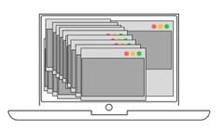 | Tabs organise a program into separate pages.


Year Five – Computing - Coding

