Subject Specific Vocabulary
tropics | The area closest to the Equator. It lies between two imaginary lines- the Tropic of Cancer and the Tropic of Capricorn.
tropical | A climate that is warm and moist (humid) all year round.
developed | A country with wealth and a high standard of living.
developing | A country with less wealth and a lower standard of living.
terrain | The surface of an area of land.
climate | The average weather conditions in an area.
humid | Warm and moist weather conditions.
vegetation | Plant life.
biome | An area with a similar climate where similar animals and plants live.
deforestation | When humans cut down or burn large areas of forest to make space for farmland, plantations or to use the trees for fuel.
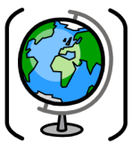

Year Five – Geography: Am I too small to make a difference?
 | Sticky knowledge
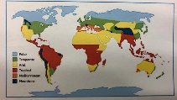 | The equator is an imaginary line that divides the world into the Northern and Southern Hemispheres. It is significant because continents have different climates depending on where they are in relation to the equator. The climate of a place can be interpreted by the types of weather, plants and animals found there. Tropical rainforests are mainly located between the Tropic of Cancer and the Tropic of Capricorn. The climate zones are: tropical, arid, temperate, continental and polar.
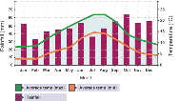 | We analyse temperature by comparing it on a line graph. We analyse rainfall by comparing it on a bar graph. Squared paper should be used to record graphs. An X and Y axis is an essential part of a graph to show relationship.
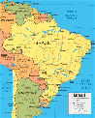  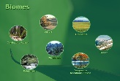 | The UK and Brazil can be compared as tourist destinations and democratic nations. The UK has a temperate climate; In contrast, Brazil has a tropical climate. Brazil has a population of around 210million, in contrast the UK has 65 million this is because Brazil is 35x bigger than the UK. The UK is an island, therefore has more than double the coastline of Brazil. The UK is a developed nation in contrast Brazil is developing. Brazil has a large rainforest.
 | A biome is interpreted as a group of plants and animals located in a specific area. Examples of biomes are rainforest, tundra, arid, grassland, aquatic and desert.
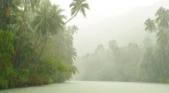 | The Amazon rainforest is mainly located in Brazil. The climate of the rainforest is humid throughout the year. It is significant to us because we get many important products from the rainforest: chocolate, Medicine (Malaria drugs), Fruits (Bananas), Vanilla Pods.
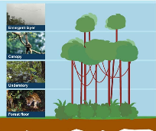 | Comparisons can be made between the 4 layers of the rainforest. These are the emergent layer, the canopy, the understory, and the forest floor. The emergent layer has lots of sunlight, very cold and windy, broad-leaved, evergreen hardwood trees; birds, monkeys, bats & butterflies. The canopy = lots of sunlight but also plenty of rain; trees with smooth, oval pointed leaves like the rubber or banana tree; snakes, toucans & tree frogs. The understory = very little sunlight but very warm and humid; small trees with low light requirements, saplings, shrubs, vines and undergrowth; insects. The forest floor = dark and no sunlight; The forest floor = very few plants grow here; gorillas, anteaters, leopards & tigers.
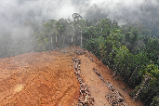 | Deforestation is interpreted as the permanent removal of trees to make room for something besides forest. It can be identified by analysing satellite images. The Amazon is significant because it is a vital carbon store that slows down the pace of global warming. Palm Oil is a major factor in deforestation.
 | Nature Conservation is a significant movement focused on protecting species, restoring habitats and enhancing ecosystems. The World Land Trust is a conservation charity that protects the world’s most threatened habitats and species, including rainforests.
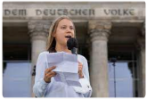 | Greta Thunberg is a significant Swedish environmental activist who is known for challenging world leaders to take immediate action for the causes and consequences of climate change.

Enhancer Sticky Knowledge
- When foods are processed they are changed e.g. grain is ground to make flour and meat is minced to make sausages.
- Foods are often processed in a factory. Convenience foods such as burgers are heavily processed and generally have ingredients added that make them unhealthy.
- Safety is away from harm or danger. Healthy meals provide the nutrients the body needs to stay healthy and function well.
. 


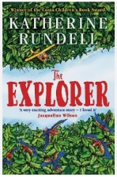
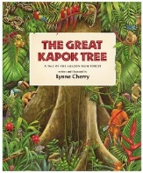

Exciting texts!
Enhancer Sticky Knowledge
- Sonny is a self-made street artist whose vibrant artworks are appreciated because they explore the causes and consequences of endangering animals. Sonny paints murals using acrylic paints and spray paint techniques. Sonny explores and appreciates the patterns of tribal art from the animals' natural habitats and uses this as inspiration for his work.
- Adding more water to a wash causes a weaker solution and consequently increases the transparency. Washes can be layered on top of each other. Using different media causes different textures (e.g. sand.) Tools can scratch into paint to add textural marks.
- A range of tools can be explored when painting (fingers, twigs, brushes). Paint brushes can be made from found objects. Layers can be explored in paintings by using similar and different media (e.g. overprinting on a wash, use of acrylic paint) Layers in paintings cause the illusion of depth in artwork.
- Value is the relative darkness or lightness of a colour. Value creates different effects such as: Using bright colours will create a positive mood.
- Dark colours will create a negative mood.

