Subject Specific Vocabulary
harmony | When two or more parts are sung or played together.
partner songs | Can be sung or played by themselves or together.
dynamics | The loudness and softness within a piece of music.
texture | Different parts playing at the same time.
melody | The melody is the main tune.
interval | The difference between notes in a piece of music.
balance | Being aware of all the elements of music, not just one part.

Year Five – Music: How does music connect us with our past?
How does music bring us together?
 | Sticky knowledge
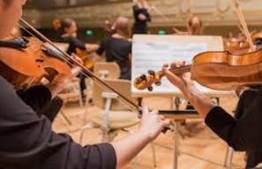 | Harmony is created when two or more different parts are sung or played together. Chords are two or more notes played at the same time.
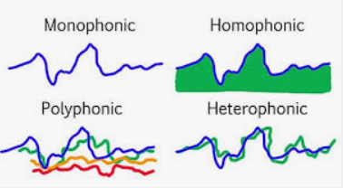 | Texture is how many parts are playing at the same time.
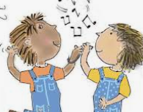 | Partner songs are songs which can be sung on their own or combined together and performed at the same time to make a new piece of music.
 | When playing together each part needs to consider their dynamics so that each part is balanced with the other (teamwork). It is important to justify why we think a piece of music is successful or unsuccessful using musical vocabulary.
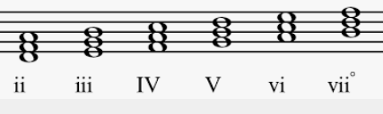 | The distance between individual notes in a melody or harmony is called an interval (2nd, 3rd, 4th, 5th, 6th, 7th, 8th or octave).
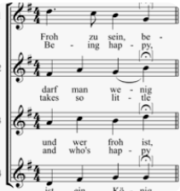 | Rounds are when the same tune is sung, but starting at different times, to create an overlapping texture.




