Subject Specific Vocabulary
reconcile | The process of bringing people with differences together and helping them understand each other.
cyberbullying | Bullying that occurs online. This could involve someone posting, commenting on or liking nasty comments about you online.
stability | A sense of safety. Things unchanging.
resolve | To come to an agreement.
trolls | People who leave intentionally provocative or offensive messages on the internet in order to get attention, cause trouble or upset someone.
reliable | Can be trusted or believed.

Year Five – PSHE: Friendships and relationships.
 | Sticky knowledge
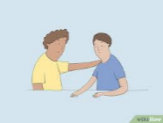 | A good friendship is when both people listen to each other and show kindness. You trust each other and feel safe to share things, knowing that the other person will keep your secrets and always treat you with respect.
 | Friendships can be like driving – sometimes they're fun and everything goes smoothly, but other times things get bumpy: you might feel upset or have disagreements. This is normal. Everyone has times when they don’t see eye to eye, but it’s important to remember that this doesn’t mean the friendship is over. It’s just part of growing and learning together.
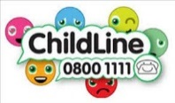 | Just like with friends you see at school or at the park, online friends should also treat you with kindness, respect, and honesty. You should always be kind, listen to them, and trust them, whether you’re talking face-to-face or through a screen. If someone online is being mean or making you uncomfortable, it's important to tell a trusted adult or contact Childline.
 | Just like with friends you see at school or at the park, online friends should also treat you with kindness, respect, and honesty. You should always be kind, listen to them, and trust them, whether you’re talking face-to-face or through a screen. If someone online is being mean or making you uncomfortable, it's important to tell a trusted adult.
 | True friends stick together, even when things get tough. If you have a problem or feel sad, a good friend will support you and help you feel better. They will also stand by you and stay loyal, not saying bad things behind your back.




