Subject Specific Vocabulary
empathy | Empathy is being able to know how someone else is feeling, even when you aren't in the same situation.
Protected characteristics | Having a protected characteristic means you have a right not to be treated less favourably, or subjected to an unfair disadvantage, by reason of that characteristic.
inequality | Not treated equally.
stereotype | An often unfair and untrue belief that many people have about all people or things with a particular characteristic.
discrimination | Discrimination is when someone treats you differently, unfairly or worse because of a protected characteristic.
inclusive | To include or make a part of something.
ethnicity | Ethnicity is defined by culture, national customs, language or beliefs.
culture | All the ways of life including arts, beliefs and institutions of a population that are passed down from generation to generation.
faith | Putting complete trust or confidence in something or someone.
differences | Not the same as…

Year Five – PSHE: What makes up a person’s identity?
 | Sticky knowledge
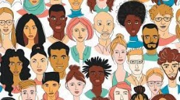 | Everyone is unique. Even if anyone else has the same name as you, they won’t be you. You are the only you in the whole world! Your thoughts, feelings, likes, and dislikes make you special, and it's good to be proud of who you are.
 | Stereotypes are a fixed image or idea of a particular type of person or thing.
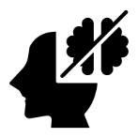 | You have qualities that make you amazing, like being kind, creative, funny, or good at solving problems. These strengths help you and others every day.
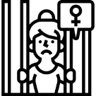 | Not everyone looks, thinks, or acts the same, and that’s a good thing. Differences make the world more interesting and help us learn from one another.






