

Aspirational Scientist:
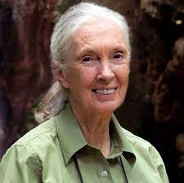
Jane Goodall is an English primatologist and anthropologist. She is famous for her study of chimpanzees. She set up the Jane Goodall institute to carry out research into protecting chimpanzees and their habitats.
Year Five – All living things and their habitats.
 | Sticky knowledge
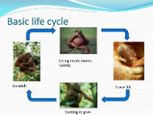 | The life cycle of a mammal orangutan - fertilised egg - baby (born as live youngsters) - child/ adolescent (human) - adult - old age.
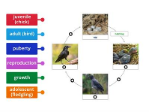 | The life cycle of a bird scarlet macaw - eggs - chick – adult.
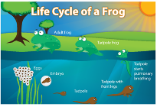 | The life cycle of an amphibian (frog) red eyed tree frog - eggs - tadpole - froglet – frog.
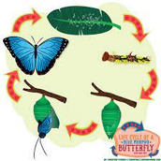 | The life cycle of an insect (butterfly) blue morpho butterfly - eggs - caterpillar - chrysalis (process called metamorphosis when young undergo a further change i.e. caterpillar to butterfly) – butterfly
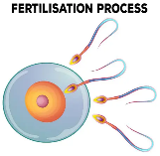 | Sexual reproduction happens when an egg from a mother animal is fertilised by sperm from the father animal. The fertilised egg grows into an embryo, which develops into a baby animal.
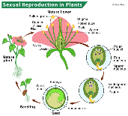 | Sexual reproduction in plants - pollen from one plant lands on the stigma of another plant (pollination) - an egg is fertilised by the pollen - when the pollen and the egg join a seed is made - the seed germinates. First, it grows into a seedling and then a full-grown plant.
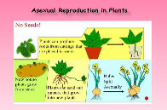 | Asexual reproduction - some plants grow into new plants without pollen or an egg. For example, plants can grow from cuttings, tubers, bulbs, plantlets runners.
Subject Specific Vocabulary
fertilisation | The process of male and female sex cells fusing together.
embryo | The earliest stage in the development of a fertilised egg.
pregnancy | When a female mammal has an unborn baby inside her.
gestation | The time between the fertilisation of the egg cell and the birth of the offspring.
metamorphosis | Striking change of form or structure in an individual after hatching or birth.
germination | The process by which seeds begin to grow into plants.
pollination | The act of transferring pollen grains from the male anther of a flower to the female stigma.
sperm | A sex cell produced by a male.
ovum | A female reproductive organ in which eggs are produced.
Working Scientifically
Observation  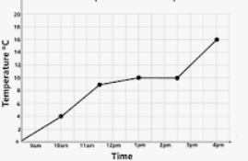 Recording

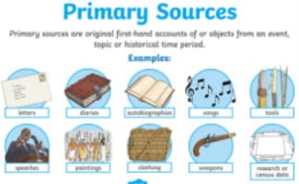
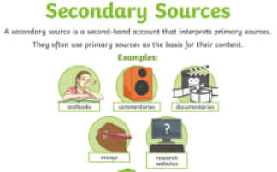
Primary and Secondary sources can help us to find out information

