

Aspirational Scientist:

Spencer Ferguson Silver III devised the adhesive that Art Fry used to create Post it Notes.
Working Scientifically
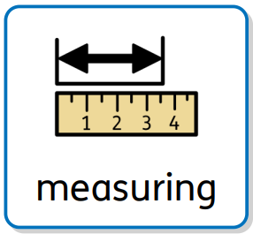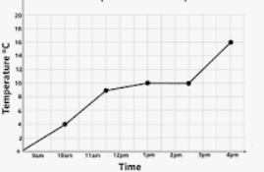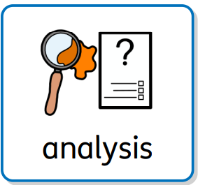
Recording
Year Five – Materials and their properties.
 | Sticky knowledge
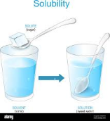 | Soluble means a material that will dissolve in water (e.g. sugar).
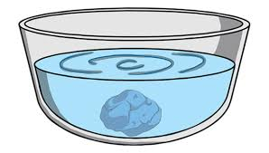 | Insoluble means a material that will not dissolve in water (e.g. a metal spoon).
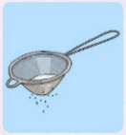 | Sieving is when you pass solids of differing sizes through a mesh/sieve. Smaller bits pass through, leaving behind the larger bits on the mesh/sieve.
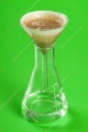 | Filtering is like sieving but involves passing a mixture of solids and liquids through a filter/mesh. The mesh/filter stops the solid parts but lets the liquid pass through.
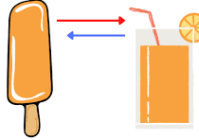 | A reversible change is when a material turns into something that looks or feels different (i.e. changing from a solid to a liquid, or liquid to a gas), but the change is not permanent. The material can be changed back.
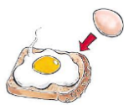 | An irreversible change results in a material changing into a completely new material.
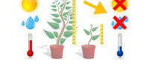 | A variable is something that you change.
Subject Specific Vocabulary
solution | A mixture of two or more substances that stays evenly mixed.
dissolve | When a solid mixes with a liquid to create a solution.
translucent | Some light passes through the material, but the light is scattered, so you can't see clearly through it.
transparent | You can see clearly through the material.
opaque | Cannot be seen through and does not allow light to pass through it.
absorbent | An absorbent material lets water soak into it.
mixture | Two or more substances that are mixed together but not chemically combined.
solid | A substance that holds its shape because it is made up of particles that are packed closely together in a fixed structure.
liquid | A substance where the particles are still close together, but not as tightly bonded or in a fixed structure like a solid. The particles slide over each other.
gas | A substance made up of high energy particles that are constantly moving rapidly.

