

Year Two – Computing: Autumn

Subject Specific Vocabulary
inappropriate | Something that is not suitable.
searches | To look for something online.
search engine | A programme that searches for items in a database.
screen time | The time given when using devices such as phones, tablets, games consoles or watching television.
digital content | Any content which is stored as digital data, such as videos, articles, and advertisements.
wellbeing | Looking after someone’s physical and mental health in a positive way.
 | Sticky knowledge
 | It is important that children between the ages of 5-17 should limit their screen time to two hours per day. Children under 2 should not have screen time.
 | The impact which too much screen time can have can impact your sleep, obesity, and neck and back problems.
 | You must not search anything inappropriate because this can affect the wellbeing of you and others.
 | Search engines can be used to find and search for things in a data base.
 | You can do research, find images and videos in a search engine online.
 | You should always make sure you know that your trusted adults are your parents, carers, teachers and your family.

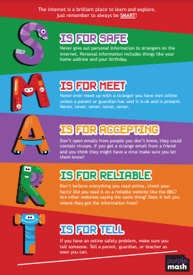
Be safe in a digital world




