Subject Specific Vocabulary
dynamics | The varying levels of volume of sound in different parts of a musical performance.
pitch | The quality of a sound caused by the rate of vibrations producing it.
pulse | A single vibration or short burst of sound.
tempo | The speed at which a passage of music is or should be played.
timbre | The quality of sound.
mood | How the music makes you feel
legato | Smooth
staccato | Short and detached
expression | The way music is performed
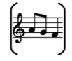

Year Two – Music: Autumn
 | Sticky knowledge
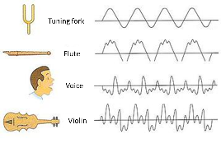 | Timbre is the quality of sound, which makes each person’s voice sound different, and each instrument sound different even when playing the same notes or tune.
 | Mood is how the music makes you feel. Different timbres can create different mood.
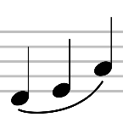 | Legato is smooth.
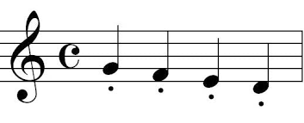 | Staccato is short and sharp.
 | Poetry is to be performed with expression using tempo and dynamics.




