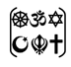

Year Two – What do Muslims believe?

Subject Specific Vocabulary
Islam | Islam is the second most popular religion in the world.
Muslim | A follower of the religion of Islam.
Allah | The Arabic name that Muslims use for God.
Ramadan | A Muslim festival where Muslims fast during the daylight and only eat after the sun has set.
prophets | Special messengers sent from Allah.
Muhammad | The last prophet and the key prophet in Islam.
Qur’an | The Holy book of Islam.
Eid | A holy celebration.
mosque | Muslim place of worship.
 | Sticky knowledge
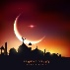 | Muslims practice the religion of Islam.
 | Muslims believe in one true God (Allah) and follow the examples of the Prophet Muhammad.
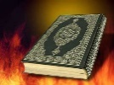 | The holy book of Islam is called the Qur’an and how it is treated with respect (It should be wrapped when not in use and always placed off of the ground on a rack or table)
 | Neither Allah or the Prophet Muhammed should be drawn or depicted in any way as it is extremely disrespectful to Muslims.
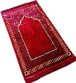 | Significant objects include prayer beads, prayer mats, Qur’an and stand.
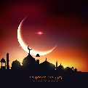 | Muslims fast during Ramadan.
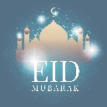 | Eid celebrations mark the end of Ramadan.

Key Belief:
Muslims believe that there is only one God called Allah. They believe Allah is the only ruler of the universe. The word ‘Islam’ means submission and obedience to Allah.

Key Belief:
Muslims follow the religion of Islam. They follow the example of the prophet Muhammad.

