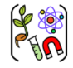

Year two – Living things and their habitats.
 | Sticky knowledge
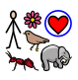 | Living things have 7 things in common. They move, respire (breathe), are sensitive, grow, reproduce (have babies), excrete (get rid of waste), need nutrition (food)
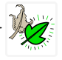 | Some things are alive, while others are no longer living or have never been living.
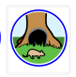 | A habitat is a natural place where a living thing lives and can survive.
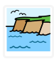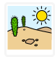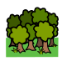 | There are different types of habitat (coastal, urban, woodland, and desert (hot and cold))
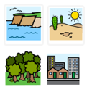 | Living things in a:  Coastal habitat include – puffins,  Urban habitats include – pigeons  Woodland habitats include – squirrels  Desert habitats include – fennec fox, jerboa, camel, cacti (hot), polar bear, seals, orca, mosses.
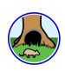 | Living things adapt to suit their habitats (big ears, come out at night, big toes – for living in hot deserts. Layers of fat, thick fur to keep warm (cold deserts), smooth bodied and webbed feet to help them swim)
Subject Specific Vocabulary
respiration | The way we breathe.
sensitivity | Using our senses to understand the world.
reproduction | Having babies and making new life.
excretion | Getting rid of waste from inside.
nutrition | Food.
dead | No longer alive.
living | Being alive.
sort | Arrange in groups.
classify | Arrange a group of objects with common features.
habitat | A natural place where a living thing lives and survives.
coastal | The place where the land meets the ocean.
urban | A habitat created by humans that includes buildings, roads, pavements well as parks and trees.
ocean | The open sea away from the coastline.
desert | Places that have very little rainfall or water.
arctic | The polar region in the north.
woodland | A habitat that has a lot of trees.
suited | It is right for living in the habitat.
adapted | The things it has that make it right for living in the habitat.

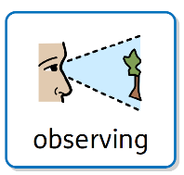
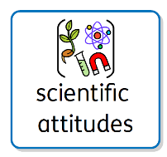
Working Scientifically

David is a naturalist and broadcaster. He has made many programmes for television about wildlife all over the world.

Aspirational Scientist:
David Attenborough


