 | Sticky knowledge
 | There is a wide range of careers available in the future and some people have many careers in their life.
 | There are different ways to look after money. Some people save and some people spend.
 | A marriage is when 2 people are joined together under the eyes of the law. Some people choose to do this through a civil partnership, which was created for 2 people of the same gender.
 | Forced marriage is illegal.
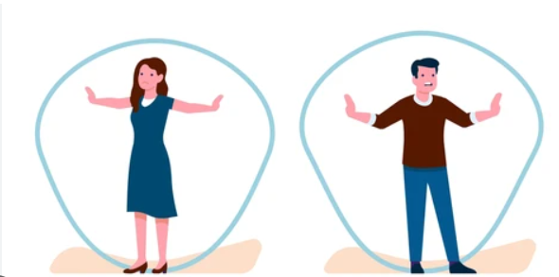 | Lots of people have different personal boundaries and things they do and do not like from others. We respect these boundaries.
 | The internet and social media can have positive benefits for people. It can also have negatives and dangers.
 | Sometimes we have setbacks. We can manage these by focusing on what we have achieved and setting new goals and targets.
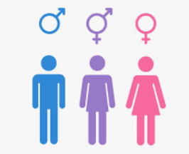 | Some people identify as a different gender to which they are born with.


Year Three – PSHE – Relationships, Work and Money
Subject Specific Vocabulary
careers | A job undertaken for a long period of a person's life and with opportunities to progress.
money | This is usually coins or banknotes to represent worth.
spending | The action or practice of spending money to buy things.
saving | The money someone has saved, especially through a bank.
unique | Being the only one of its kind; unlike anything else.
marriage | The legal union of 2 people.
civil partnership | A legal union, like marriage. It was created for people of the same gender to create a union.
union | Action of joining together.
forced marriage | When someone is forced to marry someone else. This is illegal.
illegal | To be against the law.
boundaries | The limits and rules we set for ourselves and others.
gender identity | A way to describe how someone senses their gender.
setbacks | When things seem to go backwards or don’t meet our goals.

