

Year Three – RE: Why do people pray?
 | Sticky knowledge
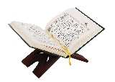 | The key prayer for Muslims is the First Surah of the Qur’an.
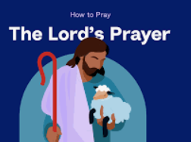 | The key prayer for Christians is the Lords’ Prayer.
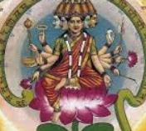 | The key prayer for Hindus is Gayatri Mantra.
 | There are different symbols that are used for prayer in different religions.
Subject Specific Vocabulary
Qur’an | The holy book for Muslims.
sacred | Connected with God.
worship | The act of praying to a god.
prayer | A regular practice and act towards God.
symbol | An image used to represent something.
commitment | Quality of being dedicated.
Allah | The name for the Muslim God.

Key Belief:
The Bible is seen as a source of authority and wisdom. Christians will use the bible in church, private worship, and prayer.
Key Belief:
Muslims believe that prayer is like a stream of living water that runs past your door. A Muslim plunges into it 5 times a day.



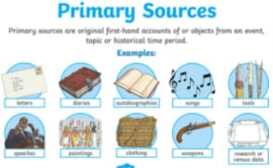
Primary and Secondary sources can help us to find out information

