

Year Three – RE: Why are festivals important to religious communities?
 | Sticky knowledge
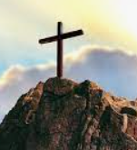 | Easter is the celebration of the resurrection of Jesus for Christians.
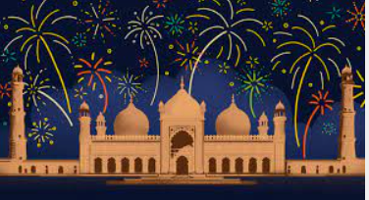 | Eid is the celebration of the end of Ramadan, where Muslims believe they are closer to God.
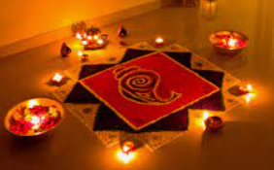 | Diwali is the celebration of good overcoming evil for Hindus.
 | Sukkot is an important Jewish festival celebrating harvest and remembering the 40 years that Jews wandered in the desert after leaving slavery.
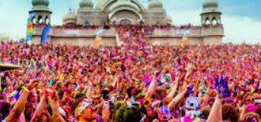 | Religious festivals:  - link to a story which is important to believers;  - express beliefs about the faith;  - involve celebrations for individuals and for the whole community;  - have an impact for the believer.
Subject Specific Vocabulary
Easter | The celebration for Christians where they remember the resurrection of Jesus Christ.
Eid | The Muslim festival celebrating the end of Ramadan.
Ramadan | The period of time when Muslims fast.
Diwali | Hindu festival with lights.
festivals | A period of celebration.
resurrection | Coming back to life.
Sukkot | The Jewish festival which celebrates the harvest.
Key Belief:
Easter is one of the main holidays, or feasts, of Christianity. It marks the resurrection of Jesus three days after his death by crucifixion. For many Christian churches, Easter is the joyful end to the Lent season of fasting.
Key Belief:
Eid is a worldwide festival and celebration for Muslims. During the calendar year there are two Eid's that are celebrated by Muslims. Eid ul Fitr, which means “festival to break the fast”, is at the end of the holy month of Ramadan in which Muslims fast for a whole month.





Primary and Secondary sources can help us to find out information

